Creating Contacts 101

- From the home page go into contacts. Use Filters to your advantage. You can filter to customers, vendors, contact etc. In this example I filtered to customers and the city of Grande Prairie.
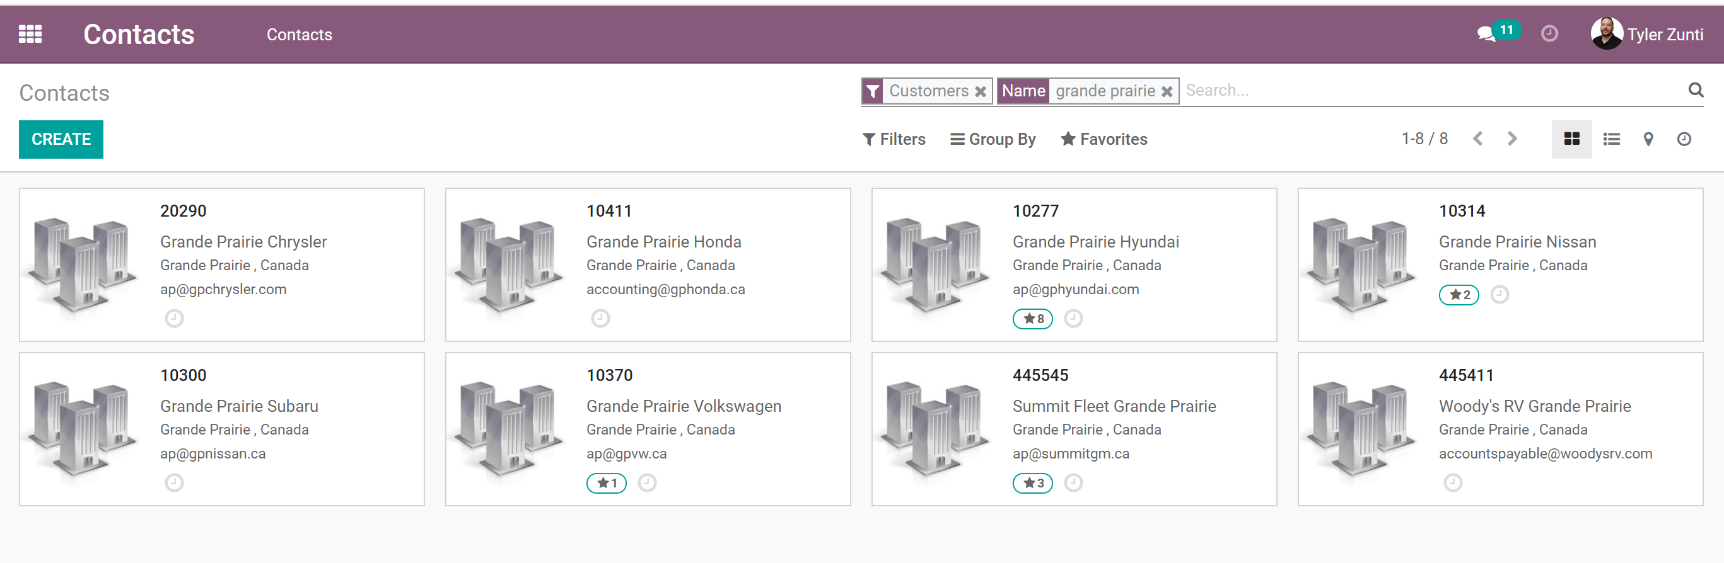
- Select the appropriate customer and select edit.
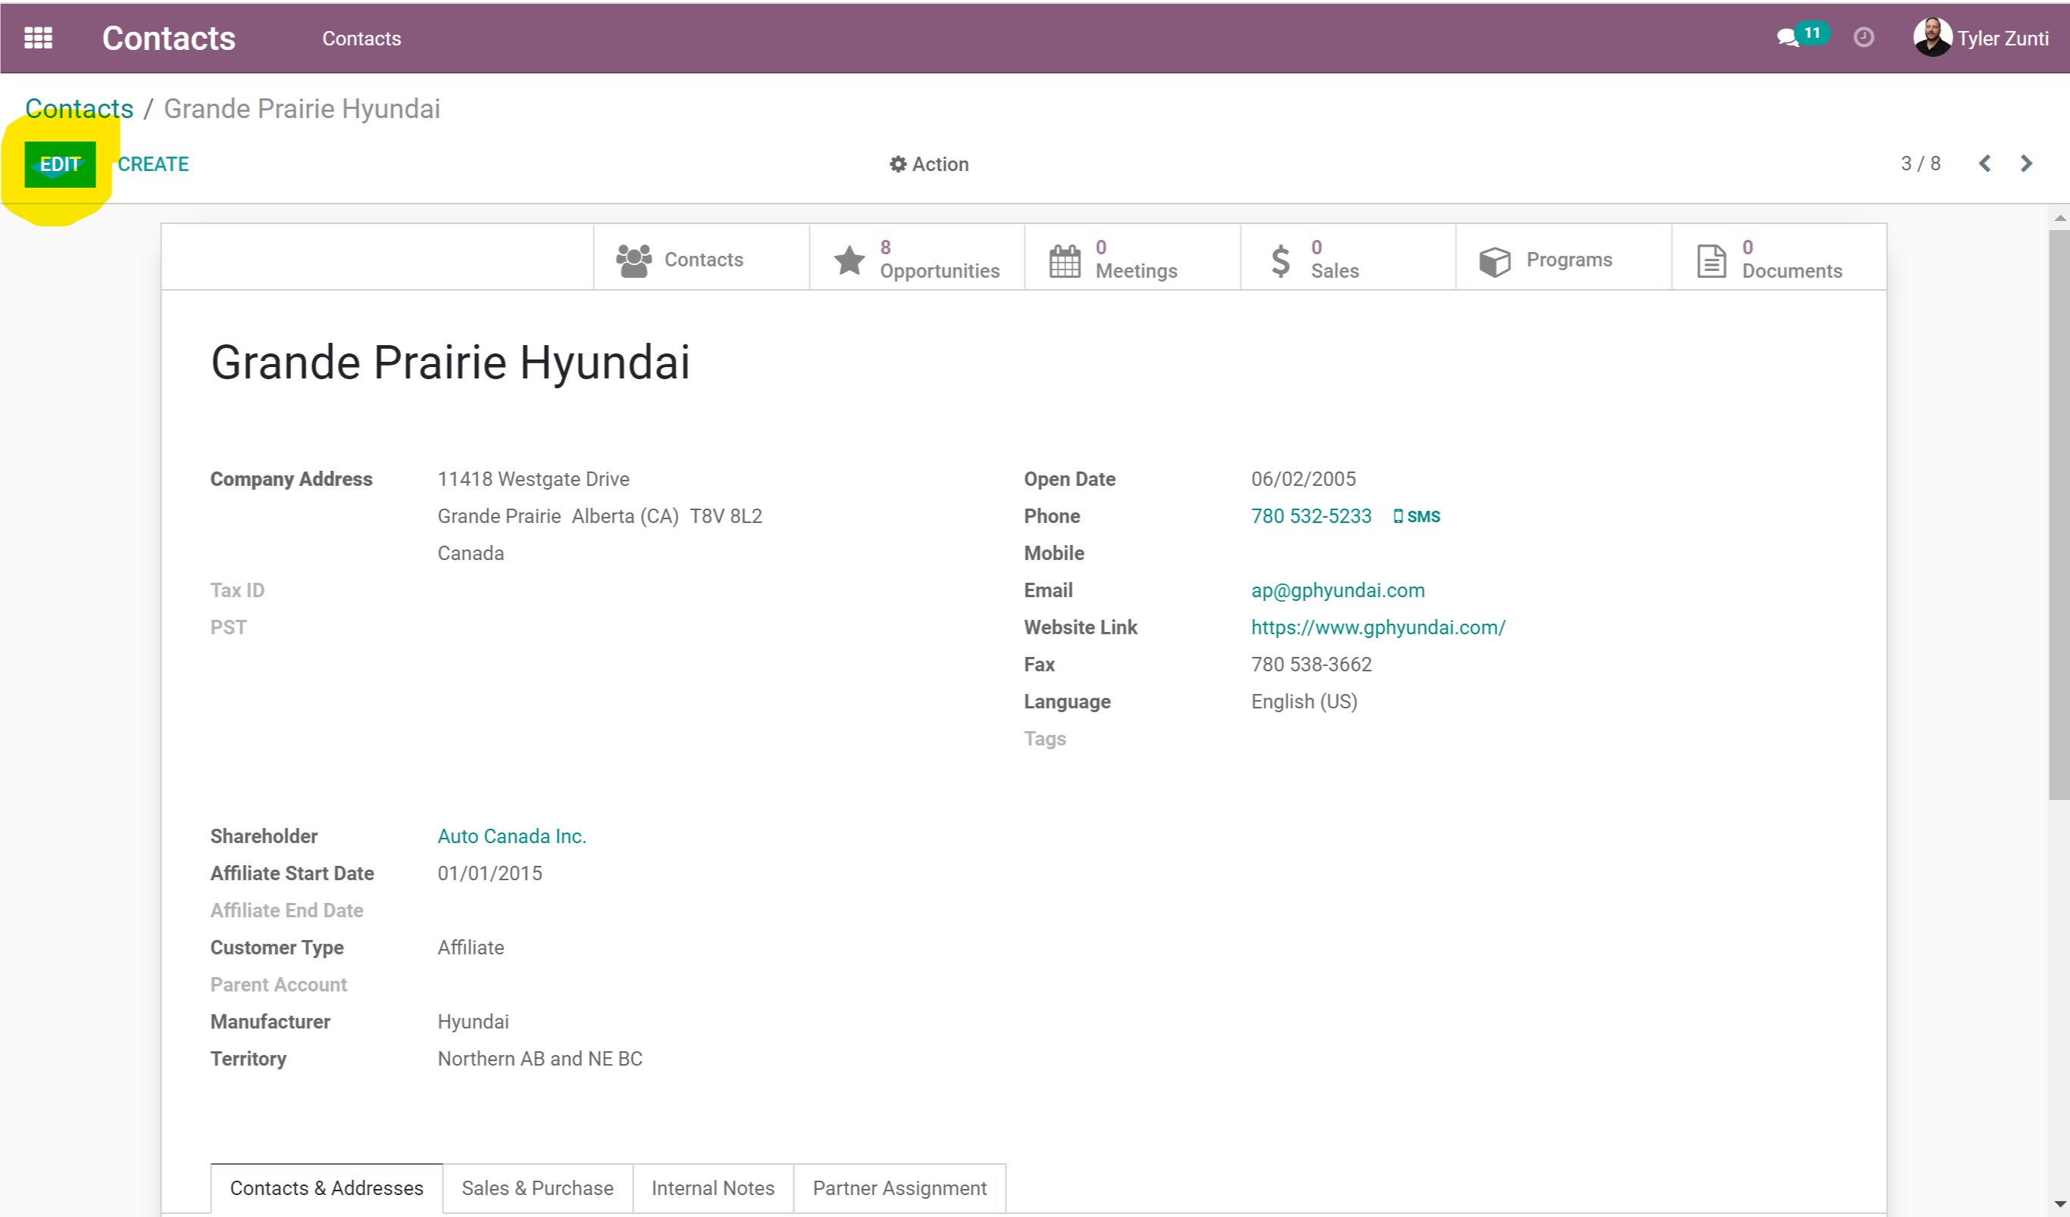

- Scroll to the contacts and select add.
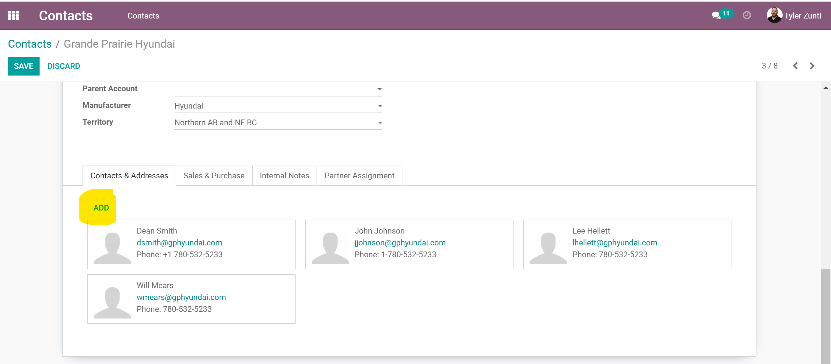

- Then select the correct contact that you would like to add. If you are adding a bill to or ship to please indicate that in the contact name.
