Creating Prospect Accounts 101

- From the home page go into contacts. Use Filters to your advantage, to confirm the account doesn’t already exist. You can filter to customers, vendors, contact etc. In this example I filtered to customers and the city of Grande Prairie. Select Create.
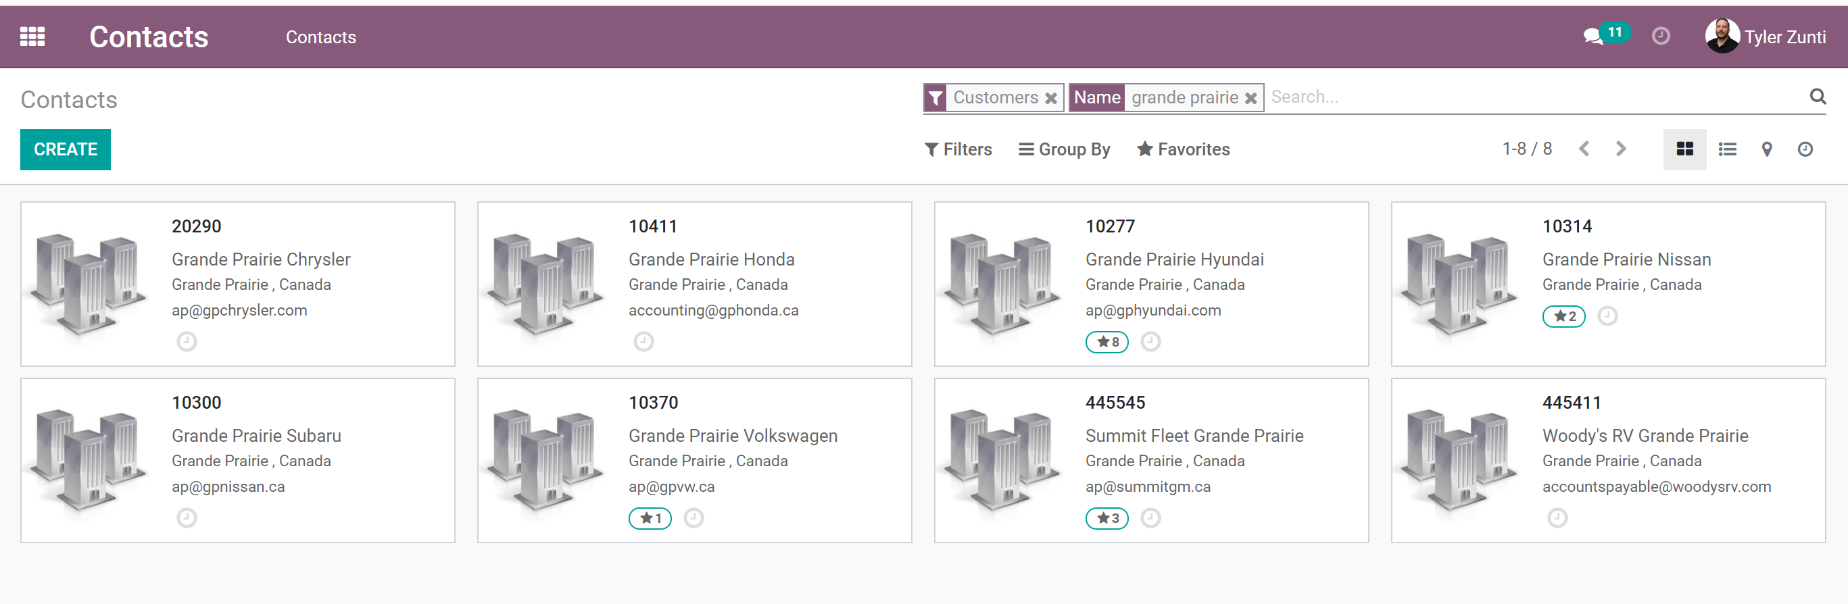
- Fill in the appropriate company details. To set up a prospect we need a minimum of Company Name, Address and Phone Number. Customer type needs to be prospect.
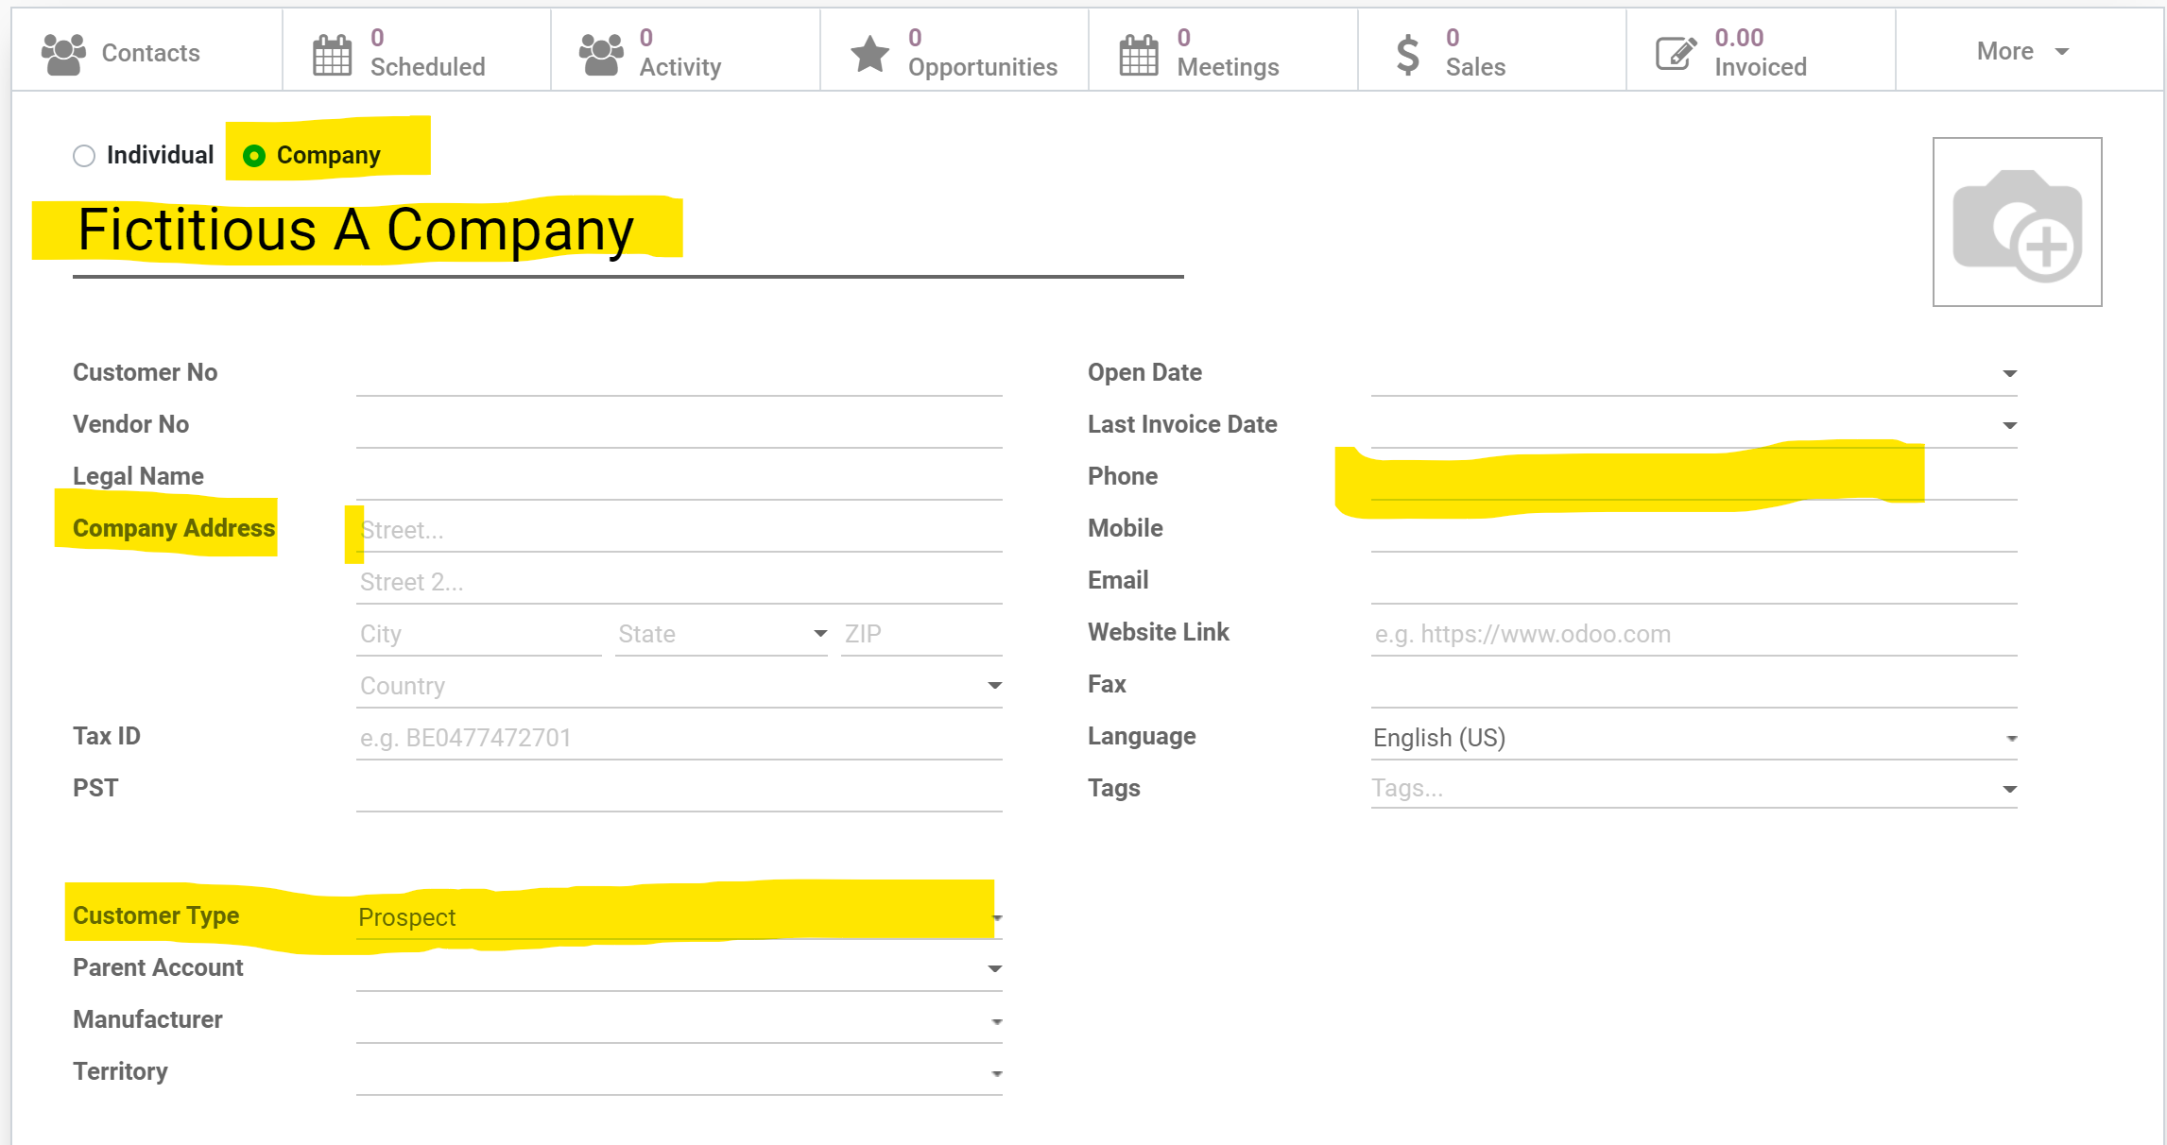

- Once you save you can add a contact like you would normally, steps are below.

- Scroll to the contacts and select add.
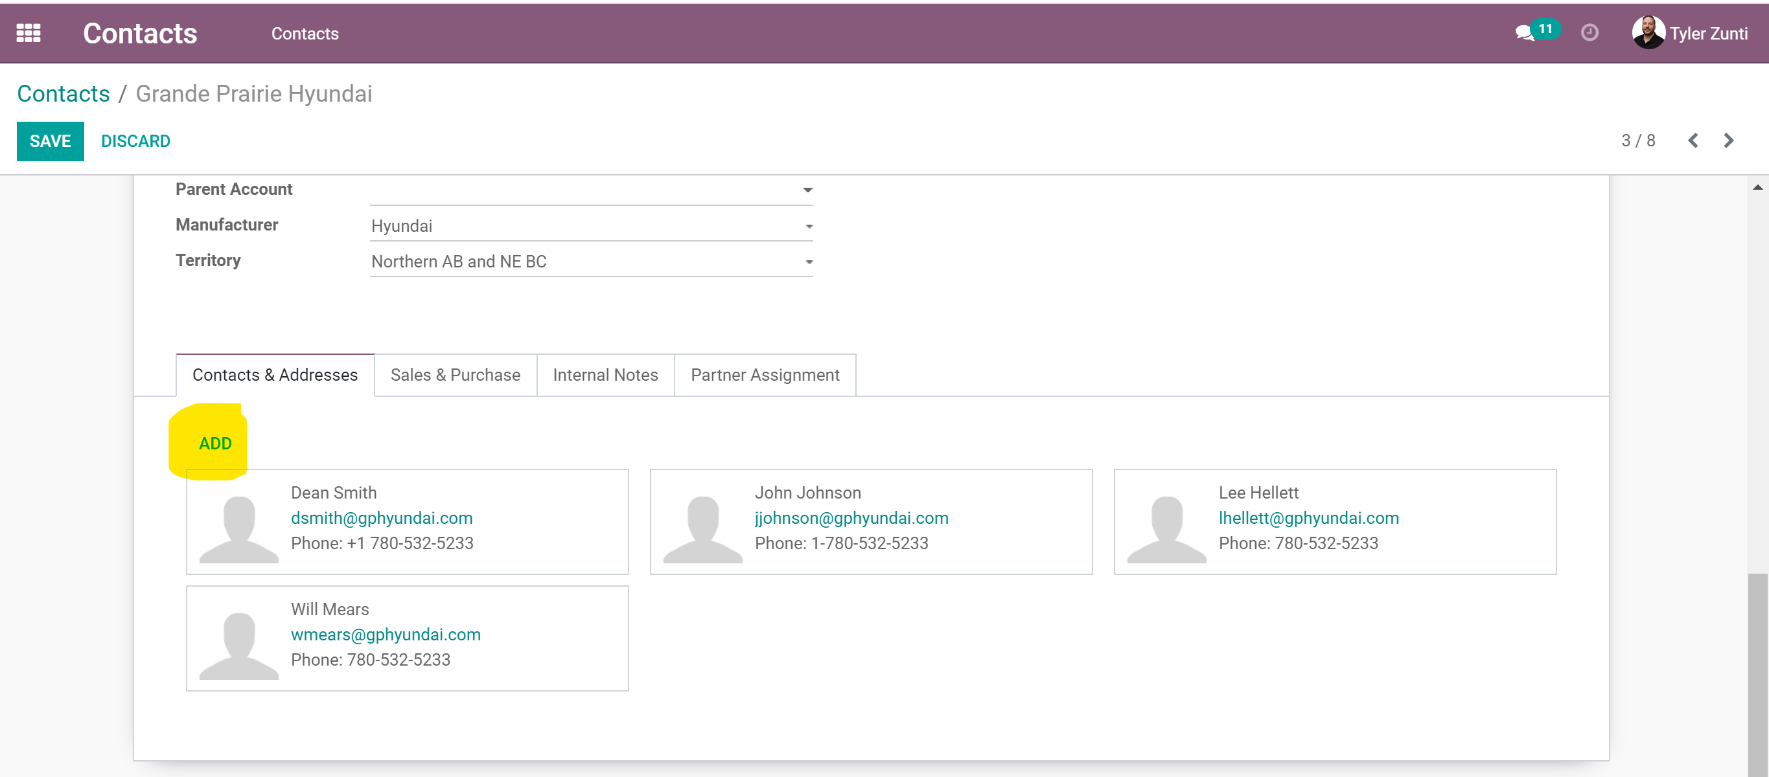

- Then select the correct contact that you would like to add. If you are adding a bill to or ship to please indicate that in the contact name.
