ODOO Tasks and Sub Tasks – Projects, Immediate Sales, and Service

- Once an opportunity is in MAS we will need to create tasks and sub tasks for the specific opportunity. The opportunity will need to have a project related to it, tasks can’t be created until there is a project related to the opportunity. If a project is not attached to the opportunity one will need to be created.
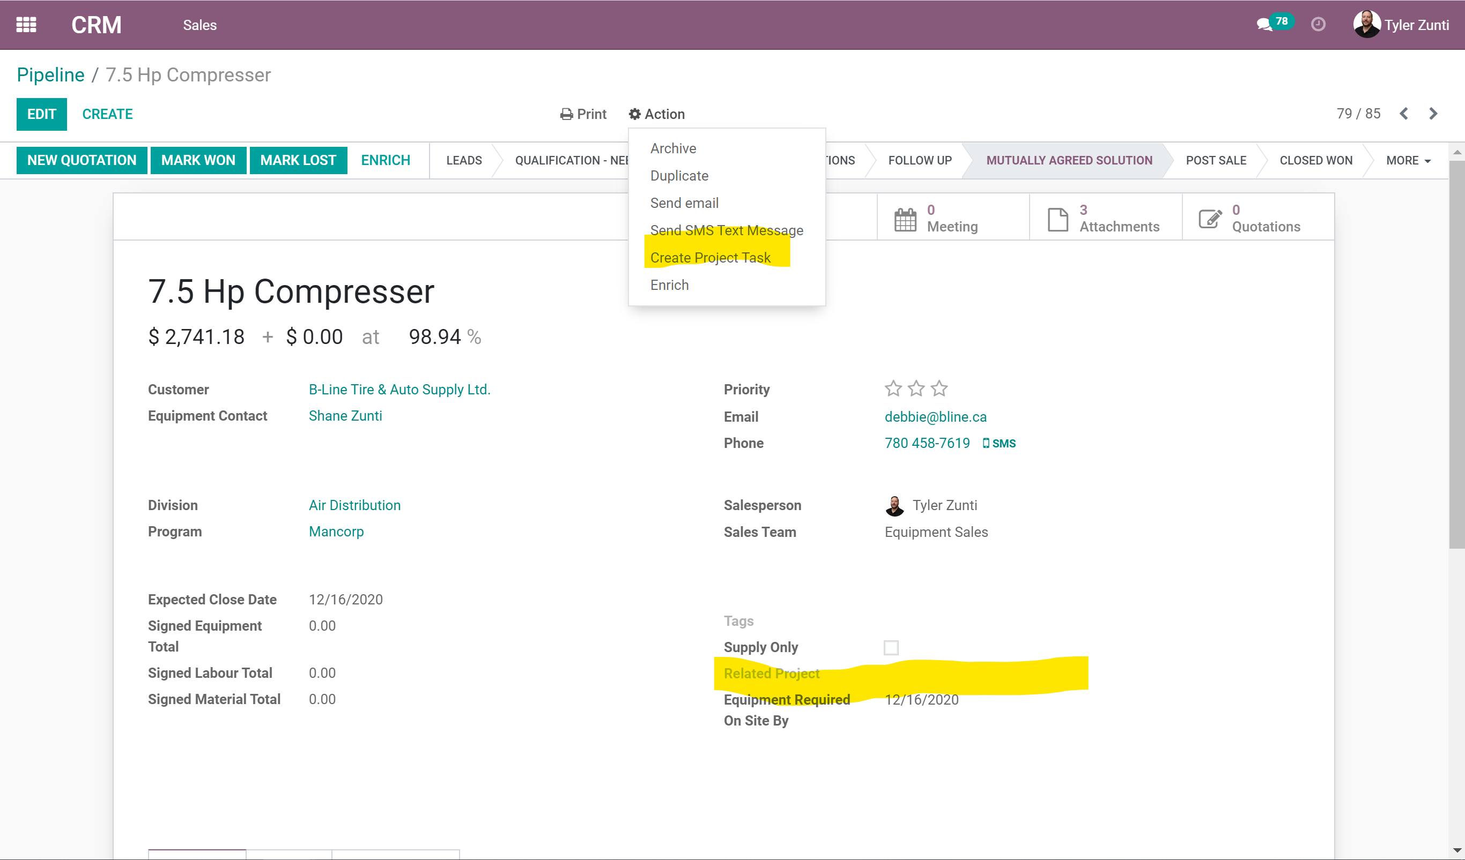
- Create a task from the action button.
- The created task will now show up in appropriate project view.
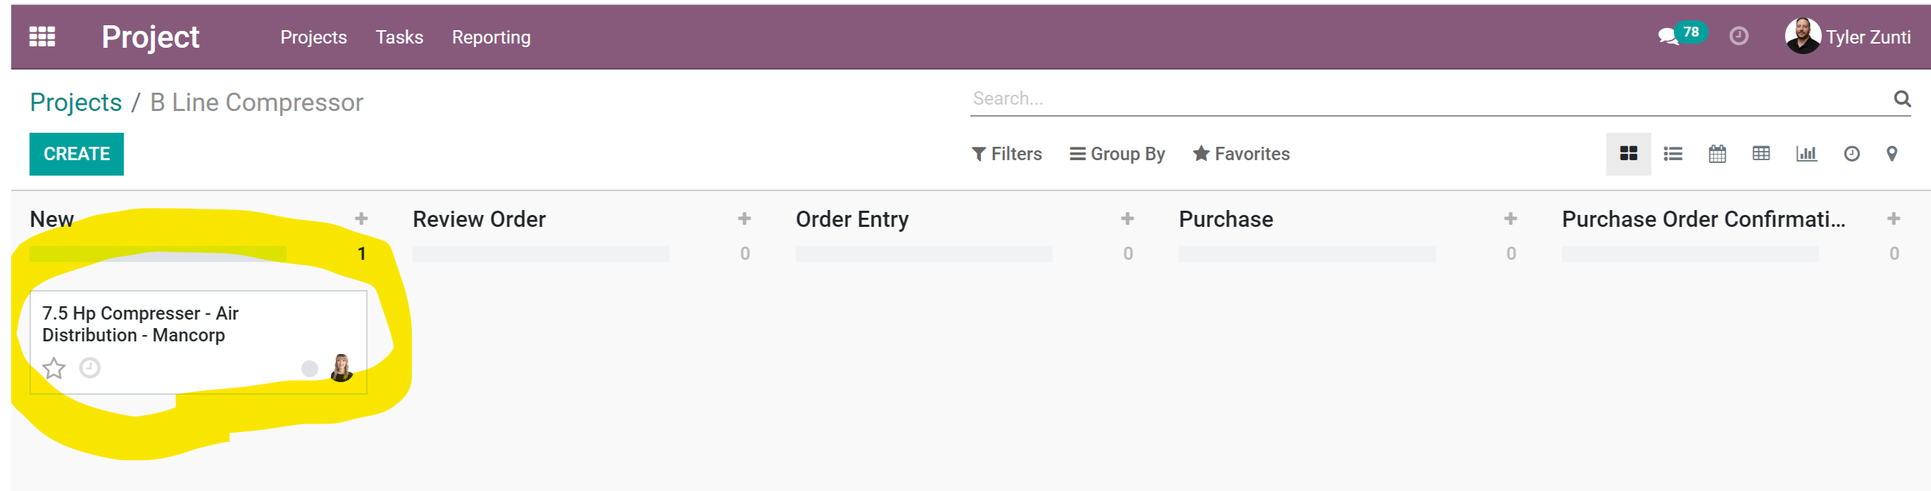

- From here you can create sub tasks for EQUIPMENT, MATERIALS, LABOUR, and RENTALS.
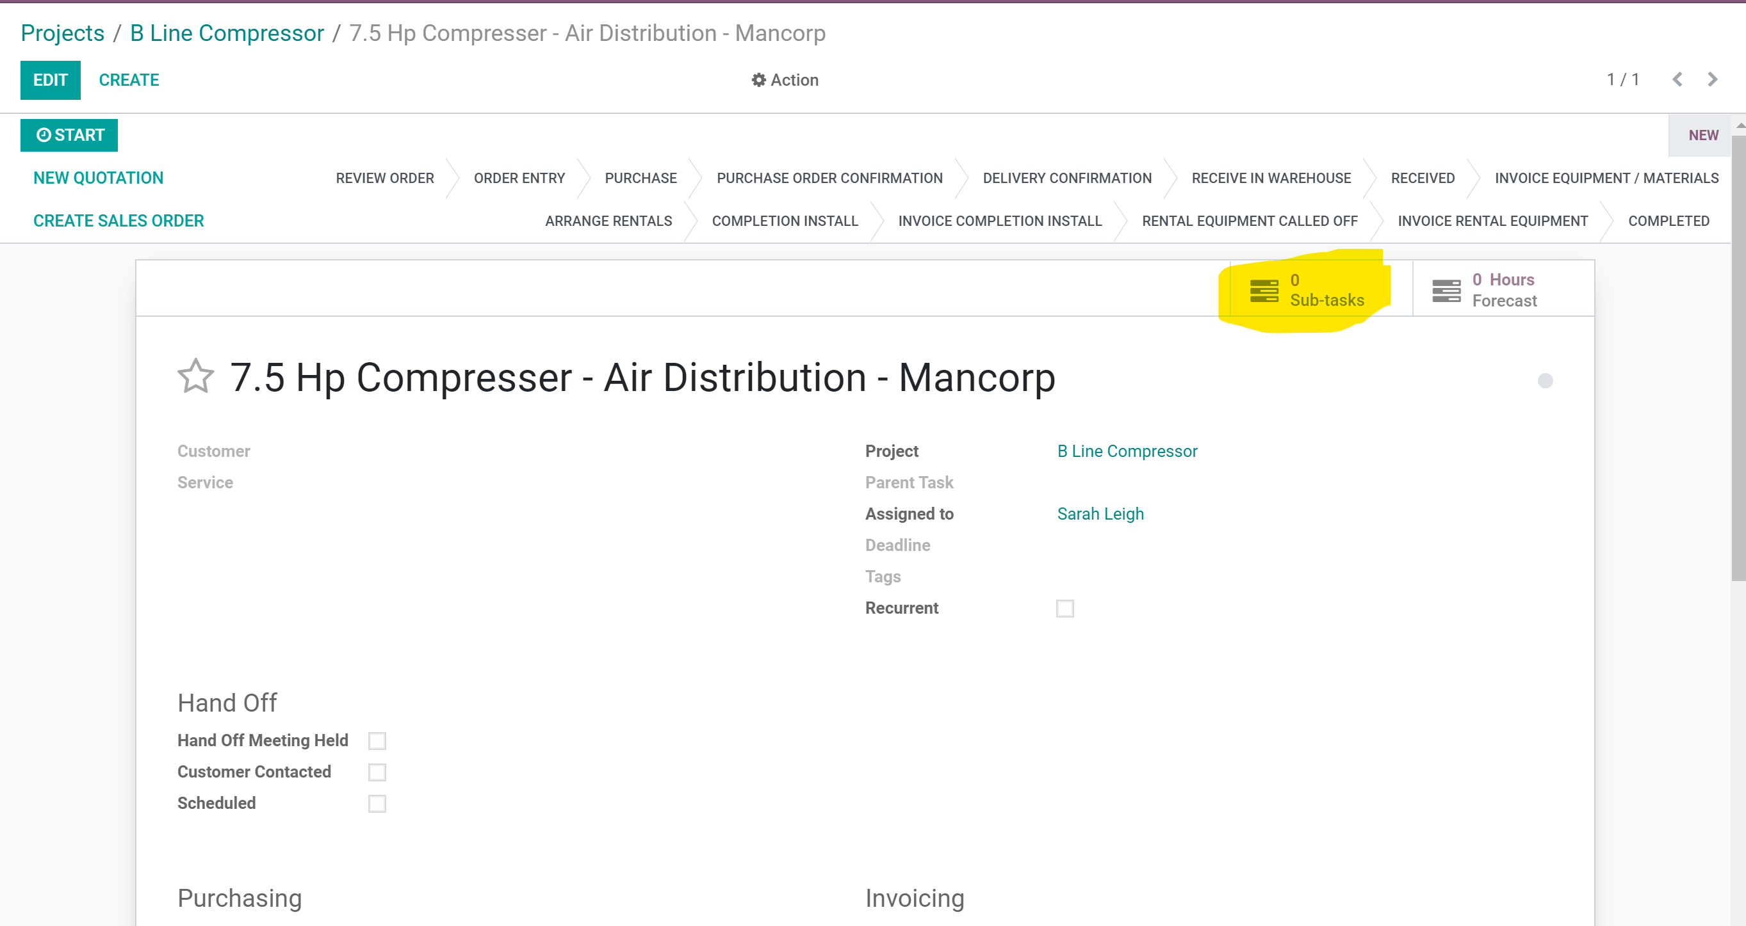

- All sub tasks will show up in the project task view. Please color code the tasks and sub tasks for easier reference later. For instance, make all the tasks of a particular opportunity blue as opportunities get added into the task view select different colors. Sub tasks need to be created for all the po’s in materials and equipment. Sub tasks need to be created for all of the labour breakdowns.
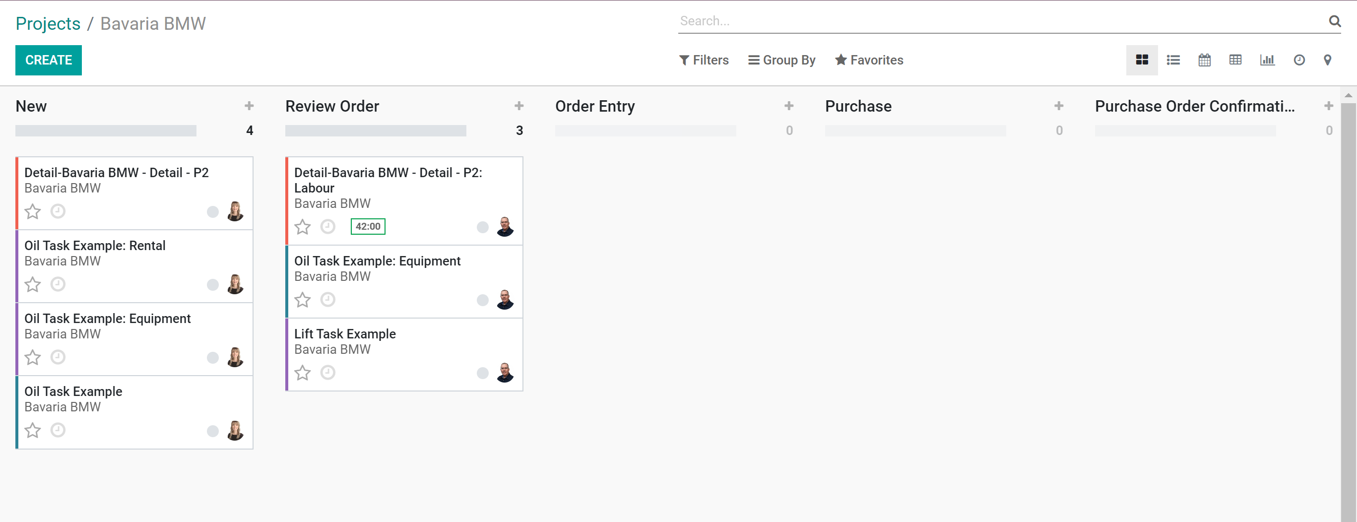

- Place tasks and sub task into the appropriate job column. Only the assigned person can remove items from the columns. If you are waiting on answers please use the reminder to do options.
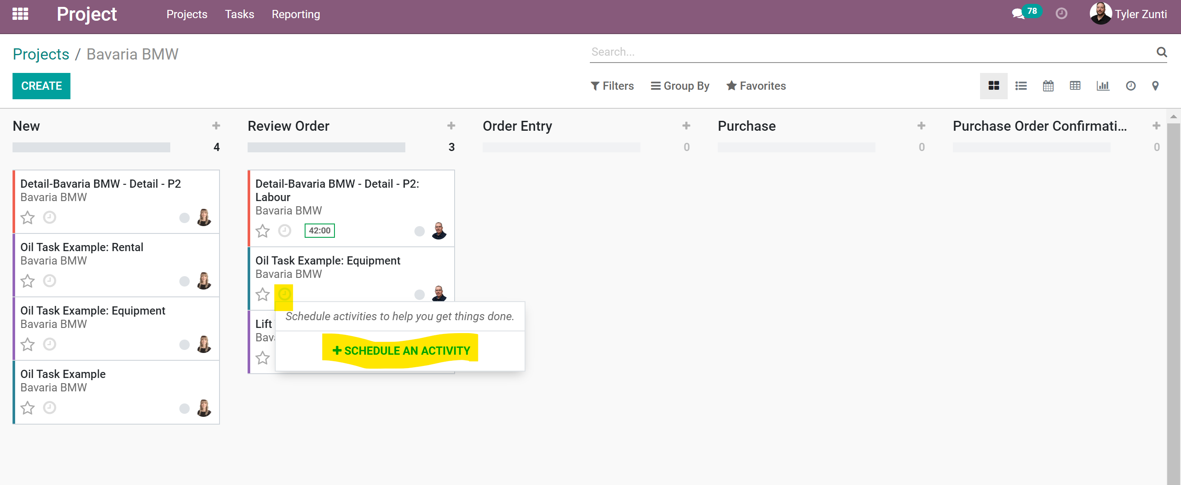
Columns are assigned to the following people.

- Fill in the appropriate info on reminders and to do’s, these will show up in a list of the person you assign them to.
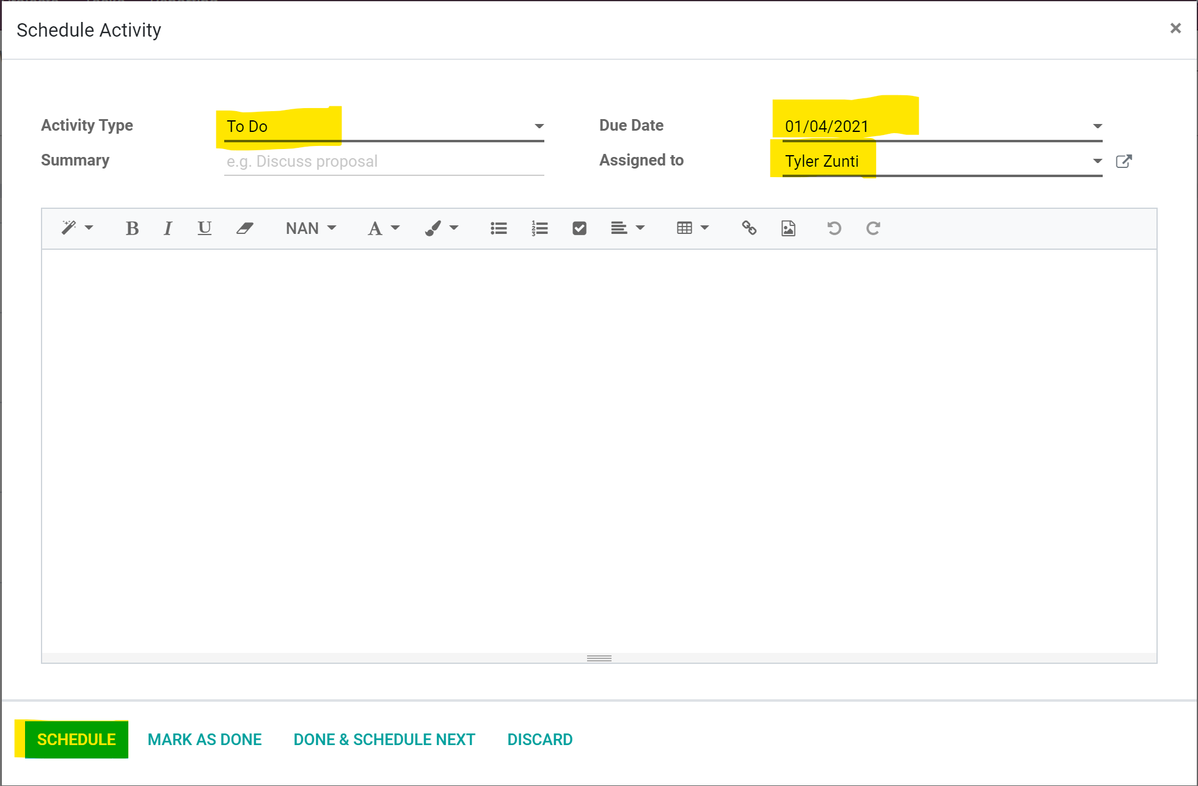

- Tasks will move from left to right as completed.

- Once all tasks have been completed the main CRM opportunity can be moved to Closed Won.

