ODOO Projects 101
- Make sure you are in the PROJECTS section of ODOO.
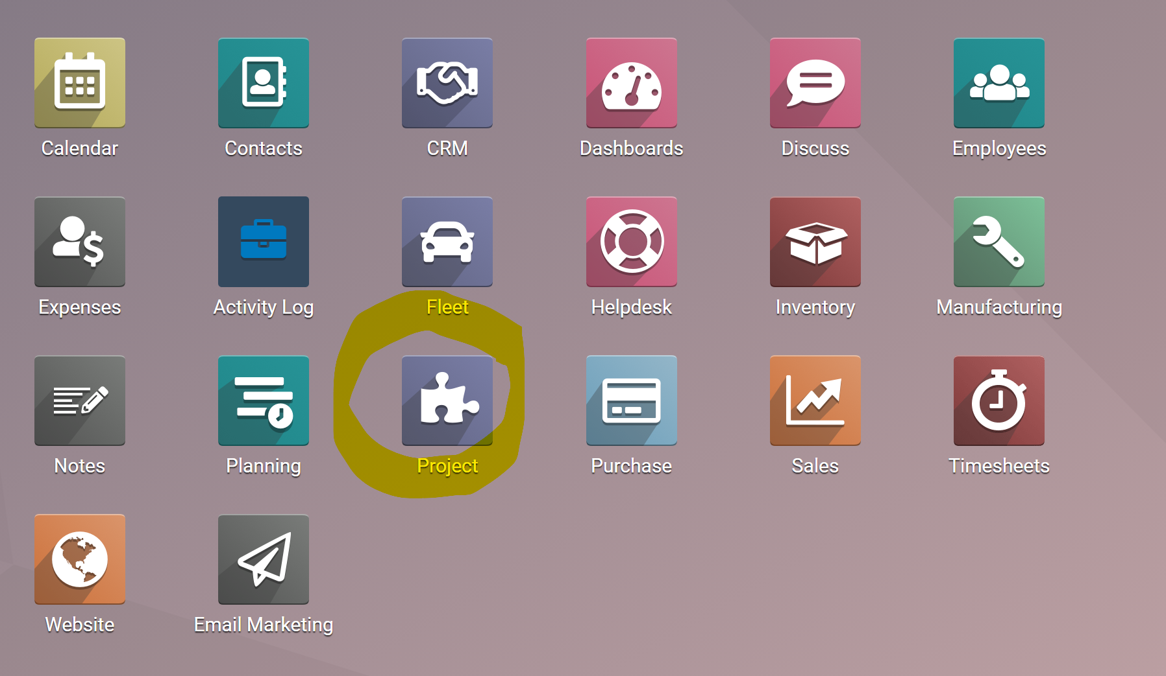
- Switch to the list view.
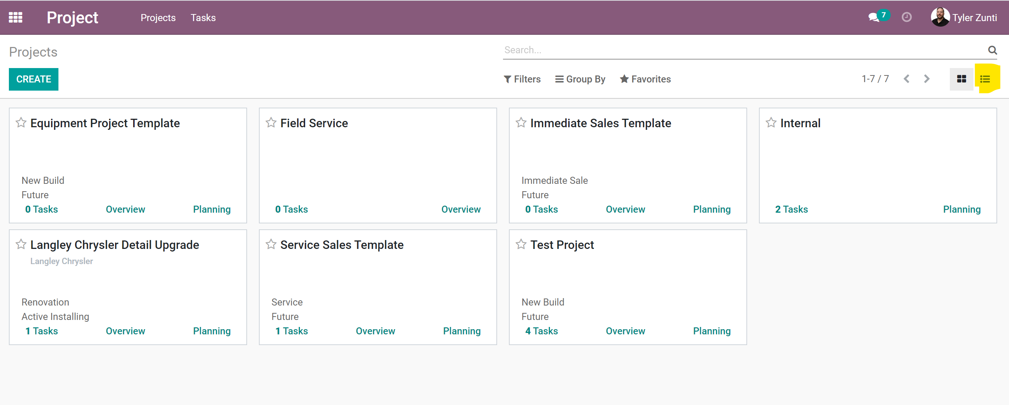
- Once you are in list view. Select Equipment Project Template and hit the action but to copy the template.
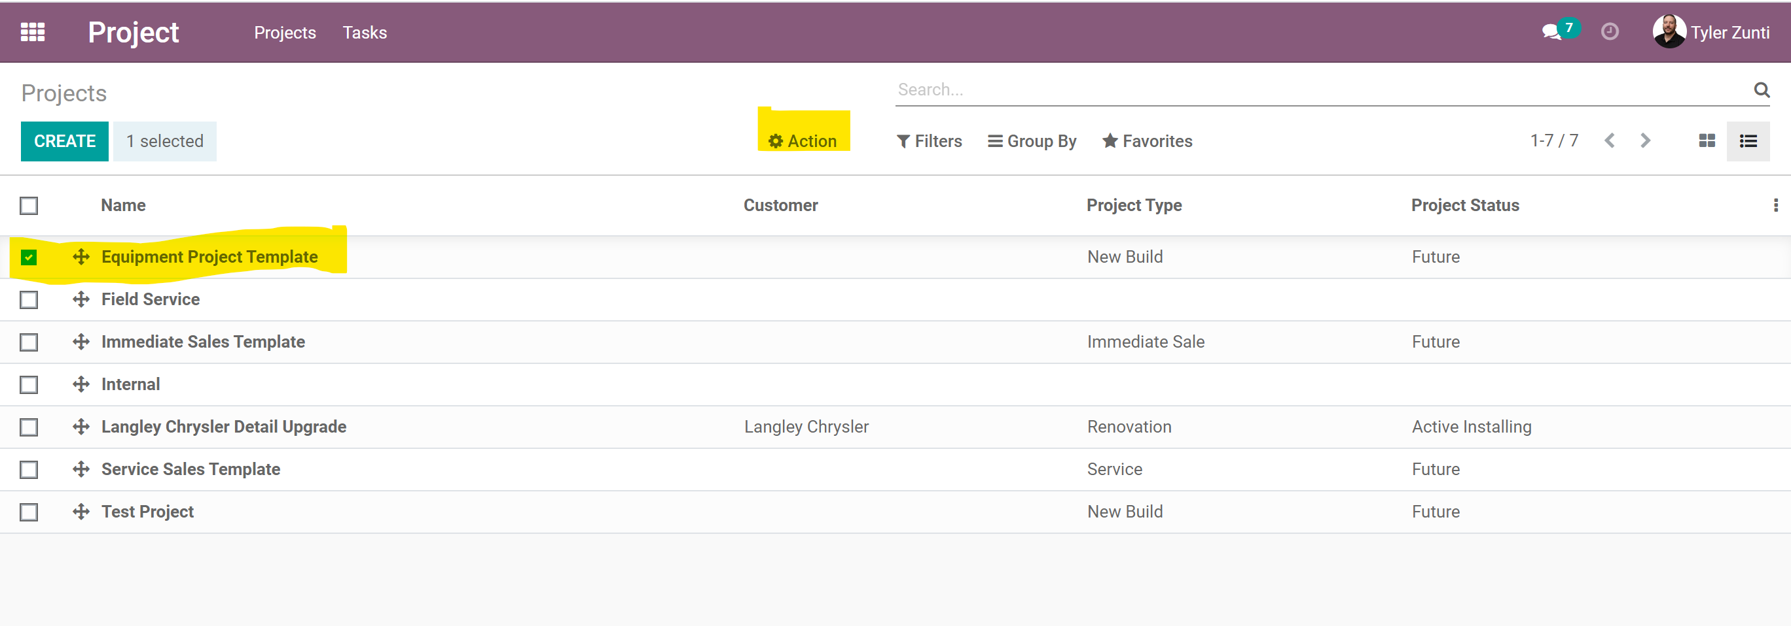

- In the copy template screen please fill in the appropriate info.

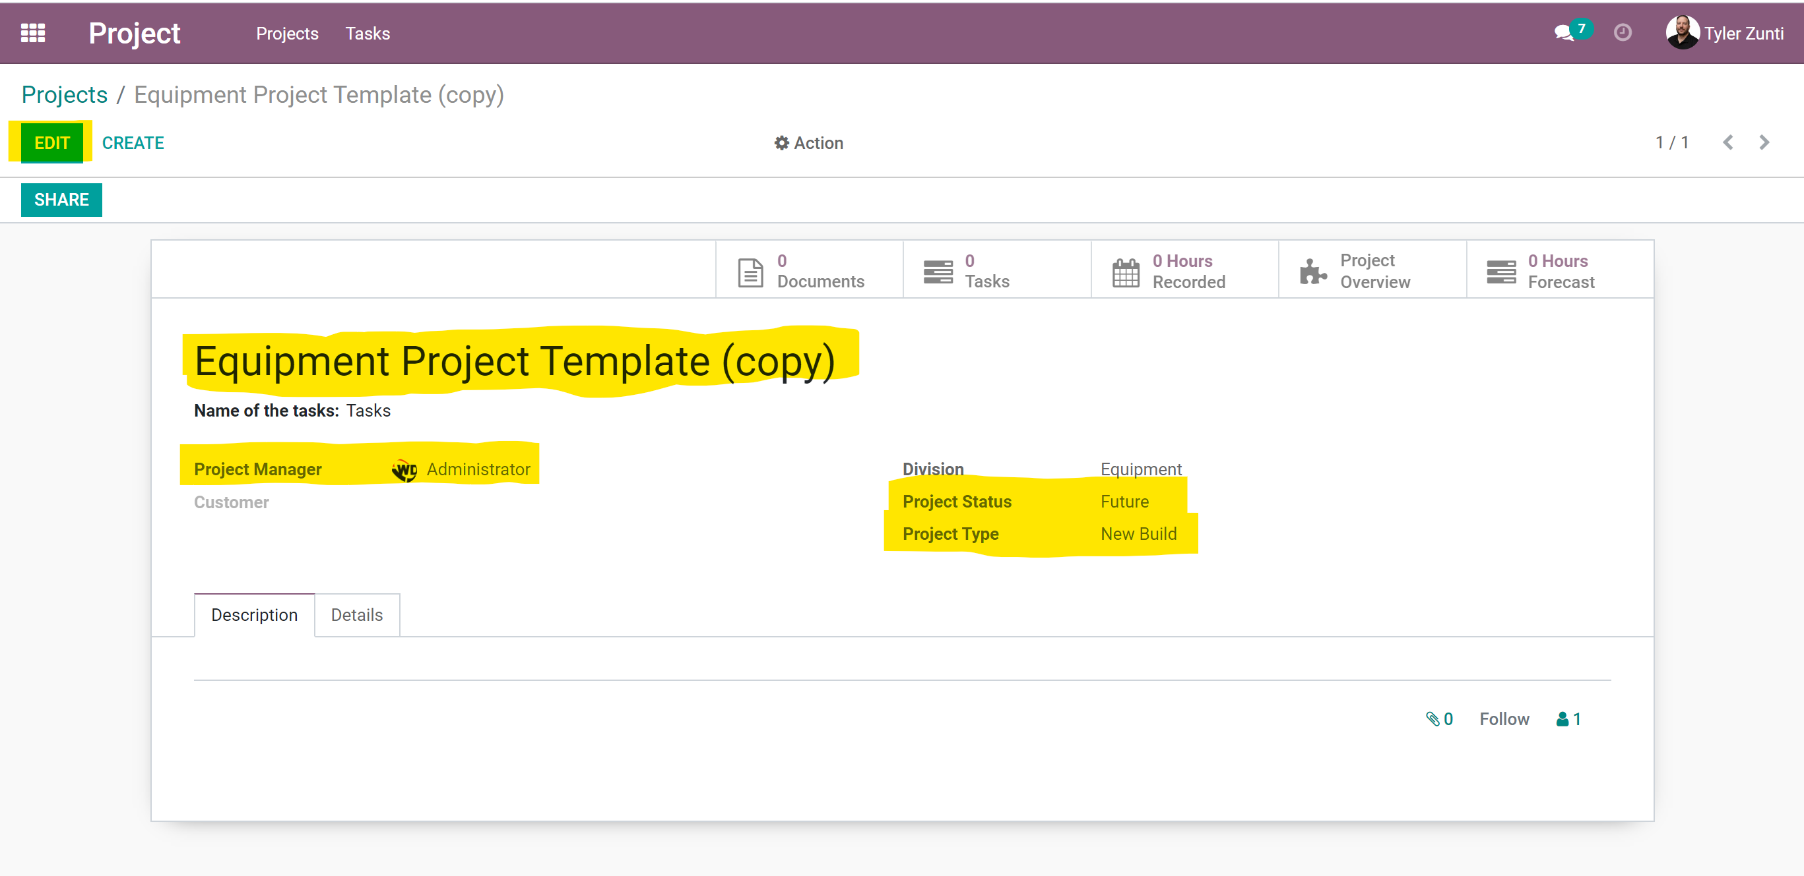

The WD project has multiple options.
Status
Future – drawing and planning phase
Active – quoting, collecting orders, installation, etc.
Deficiencies – installation complete, deficiency process intiaited.
Completed – complete

Type
Renovation – any project occupying the same address.
New build – any project occupying a new address.

- When creating potentials you can now place them into the appropriate WD project.
