ODOO Service Opportunities and Ordering

- Once you have a signed order for Service use the stars to indicate urgency. 3 Stars will indicate immediate, no stars will indicate weekly order.
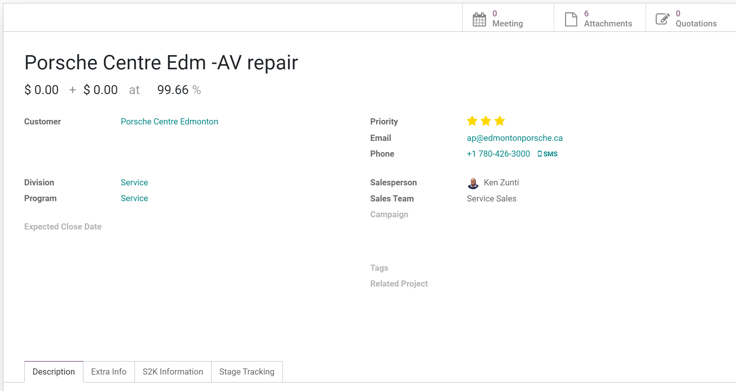
- Once the order has been created with the Odoo sub task.
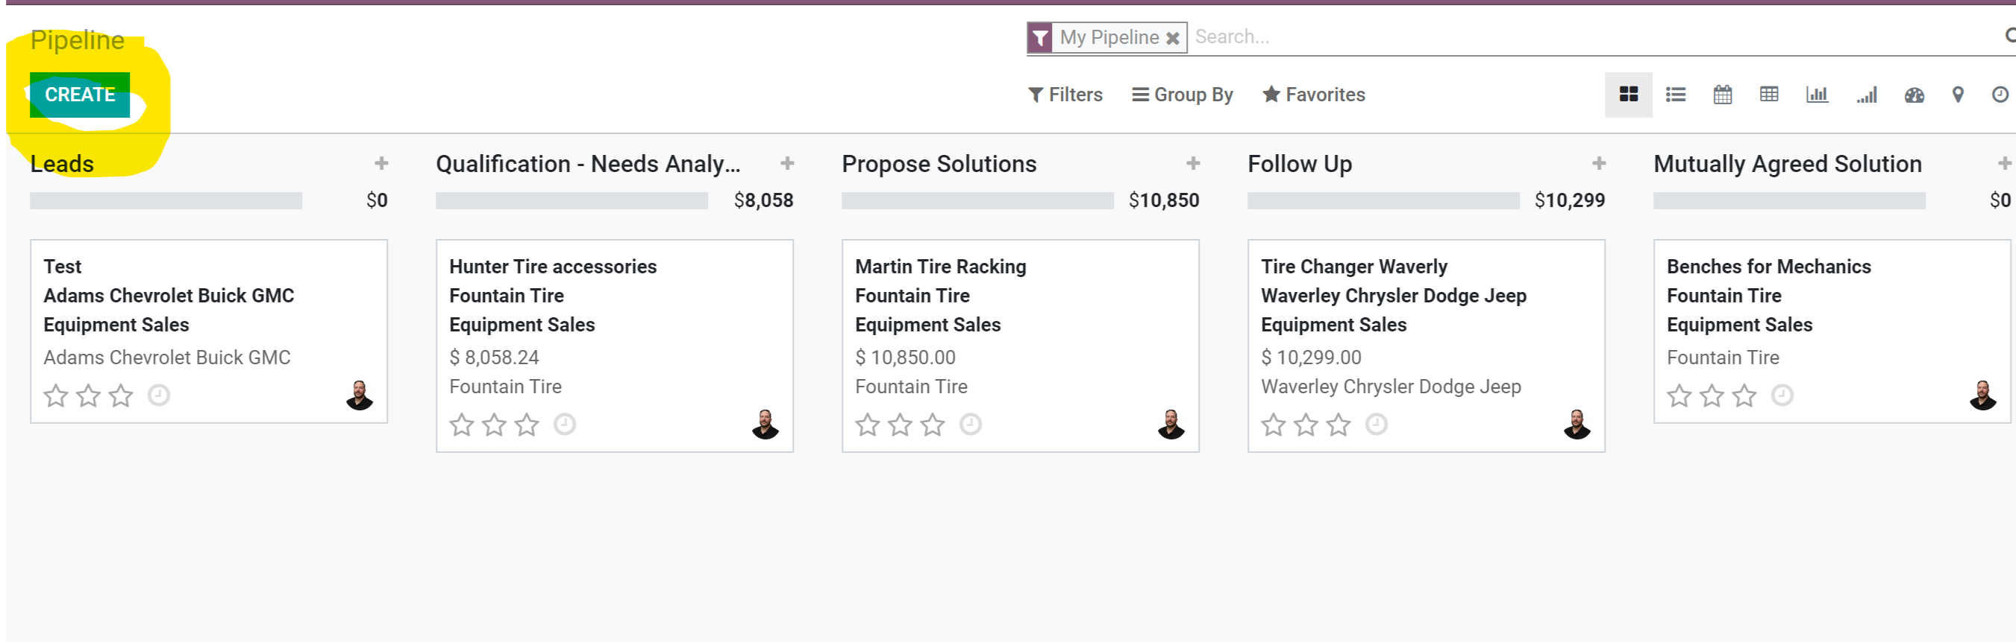
- Fill in all the highlighted fields. Expected close date is your best guess on when everything will be set to CLOSED WON. Related Project is for any project based potentials. The project needs to be created first! 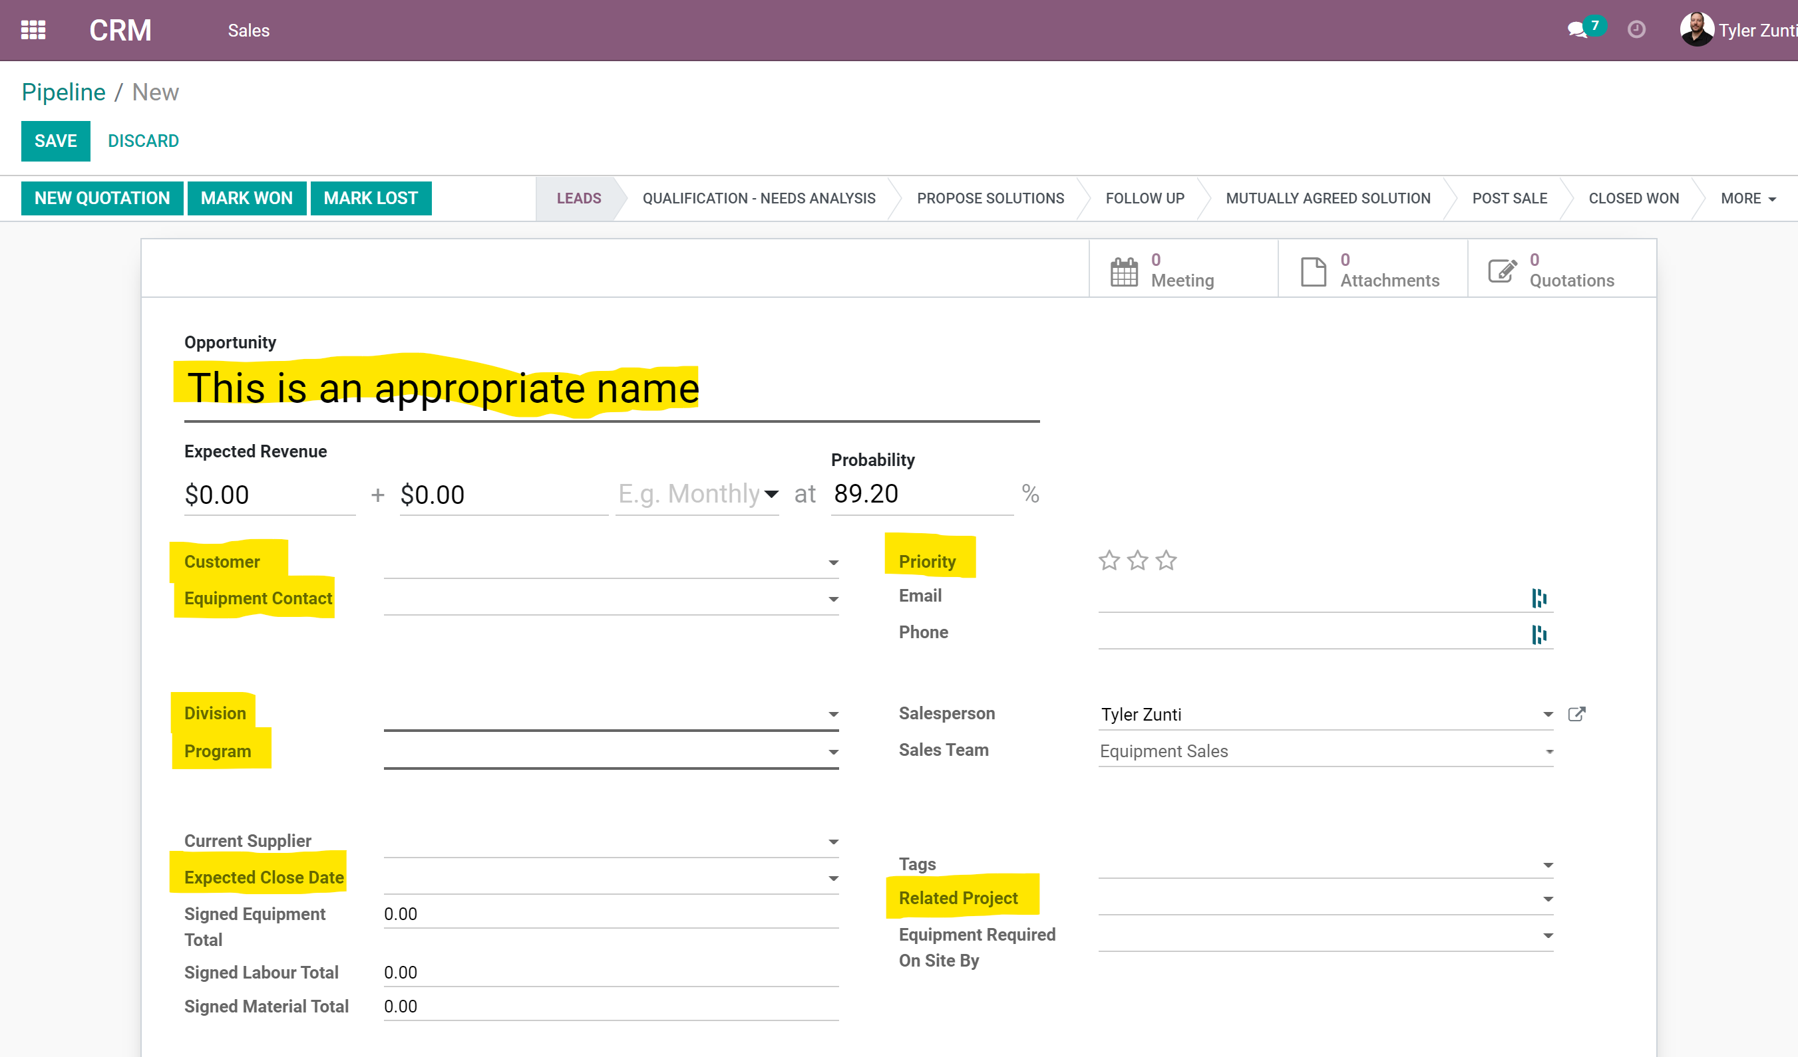

- Save the potential to move to the next stage. Please leave the potential in leads until you have all the details ready to be quoted.
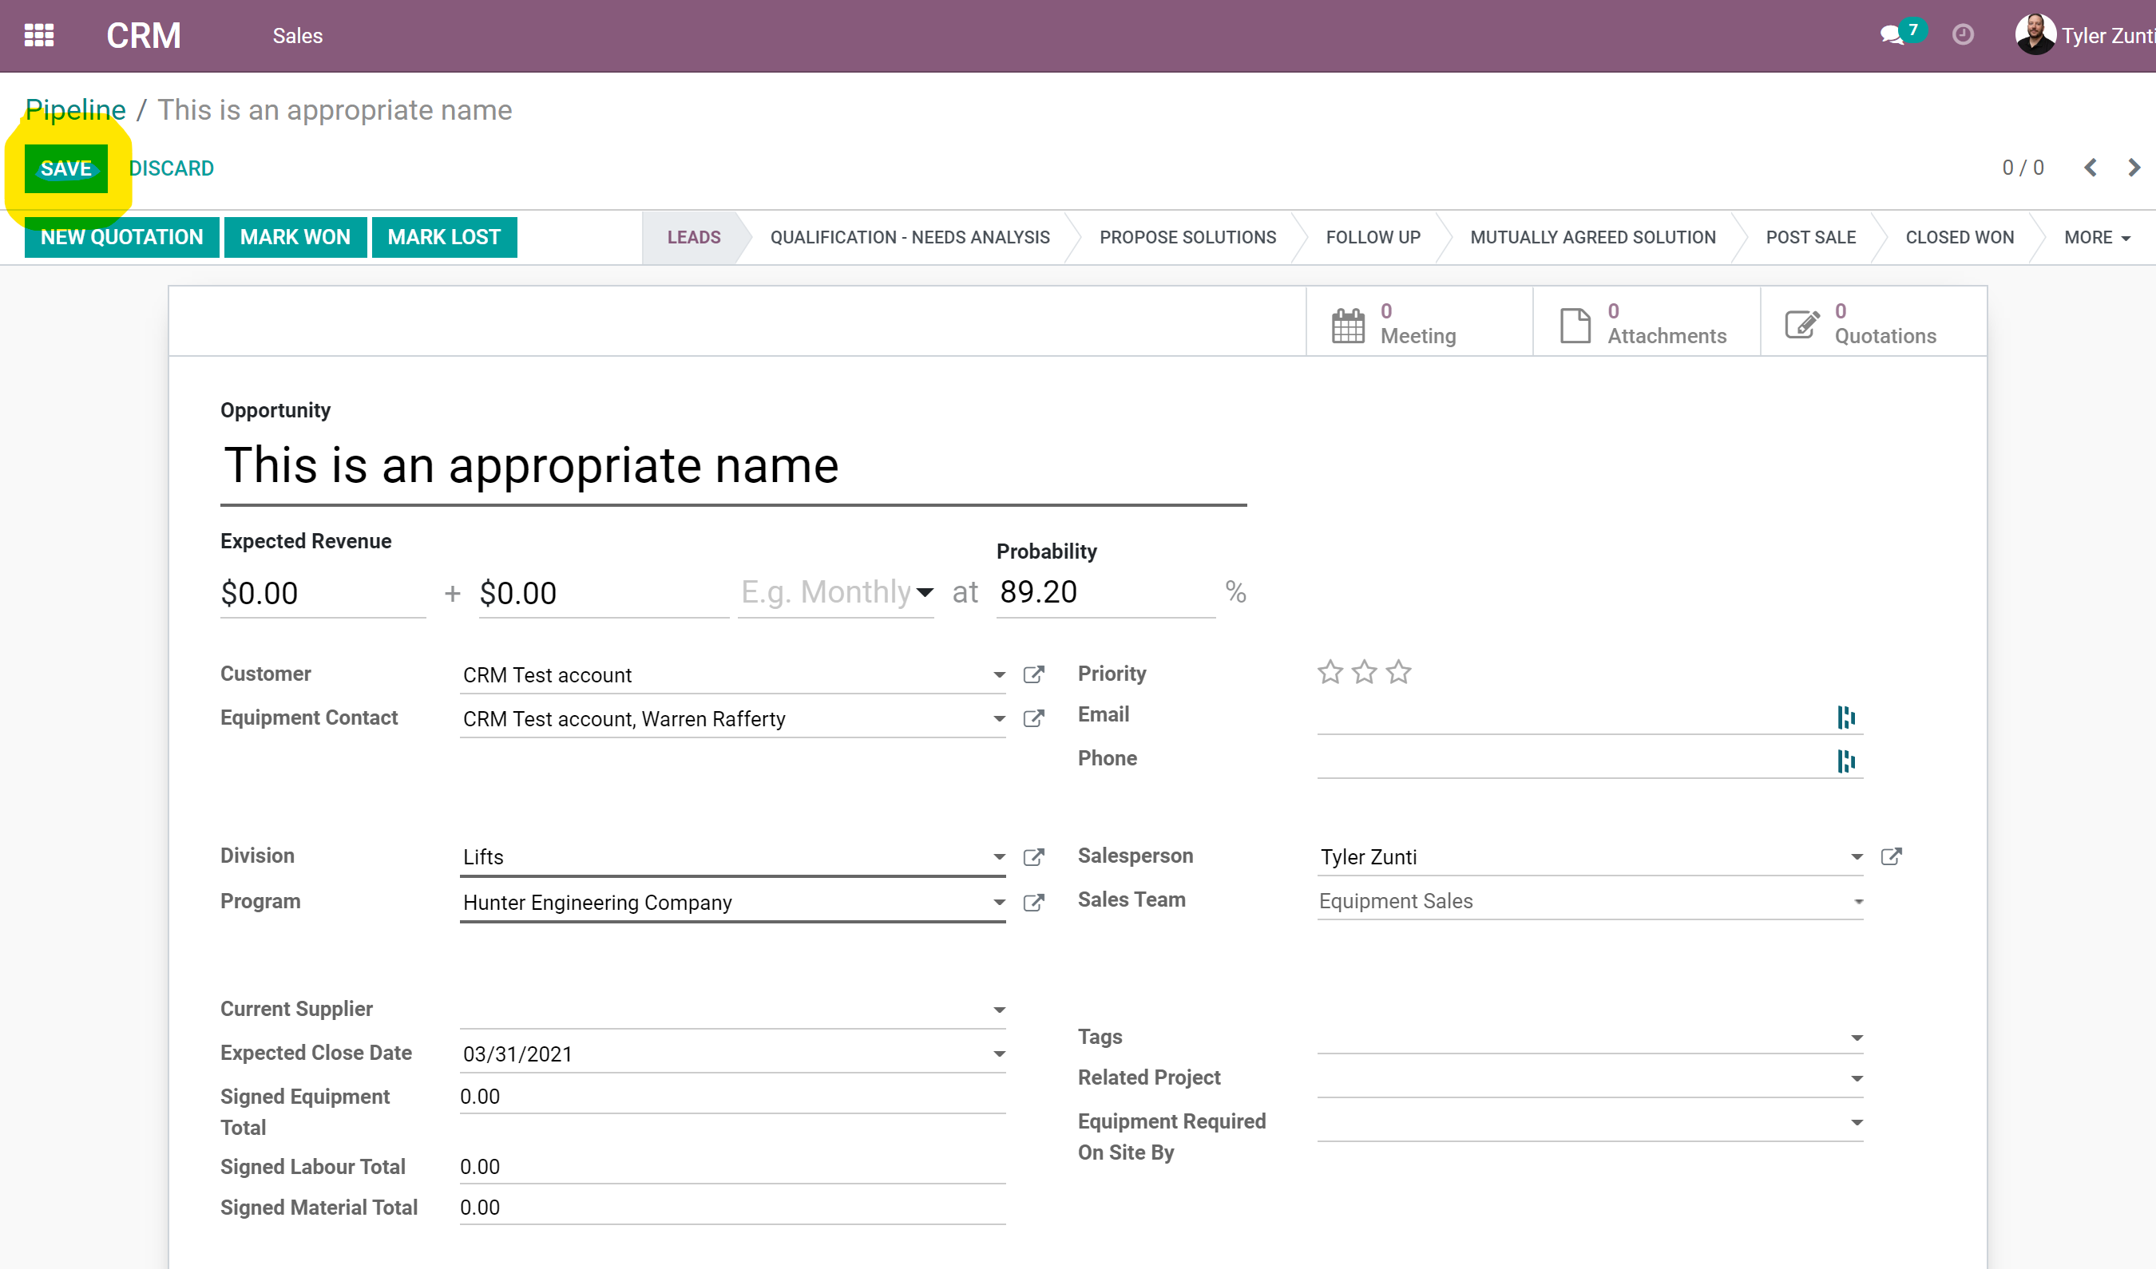

- In the notes sections please indicate what you would like. Include any vendor quotes here. Anytime you make a note for an updated quote please “@” mention the appropriate people. Don’t forget to hit LOG.
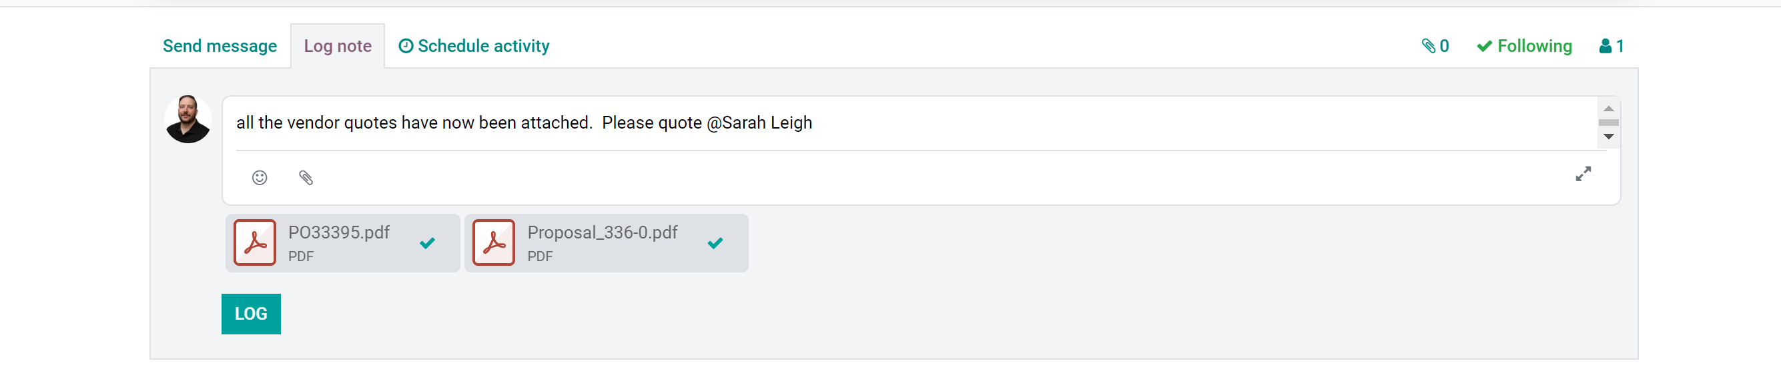
- Once the note is logged move the stage to Qualification – Needs Analysis
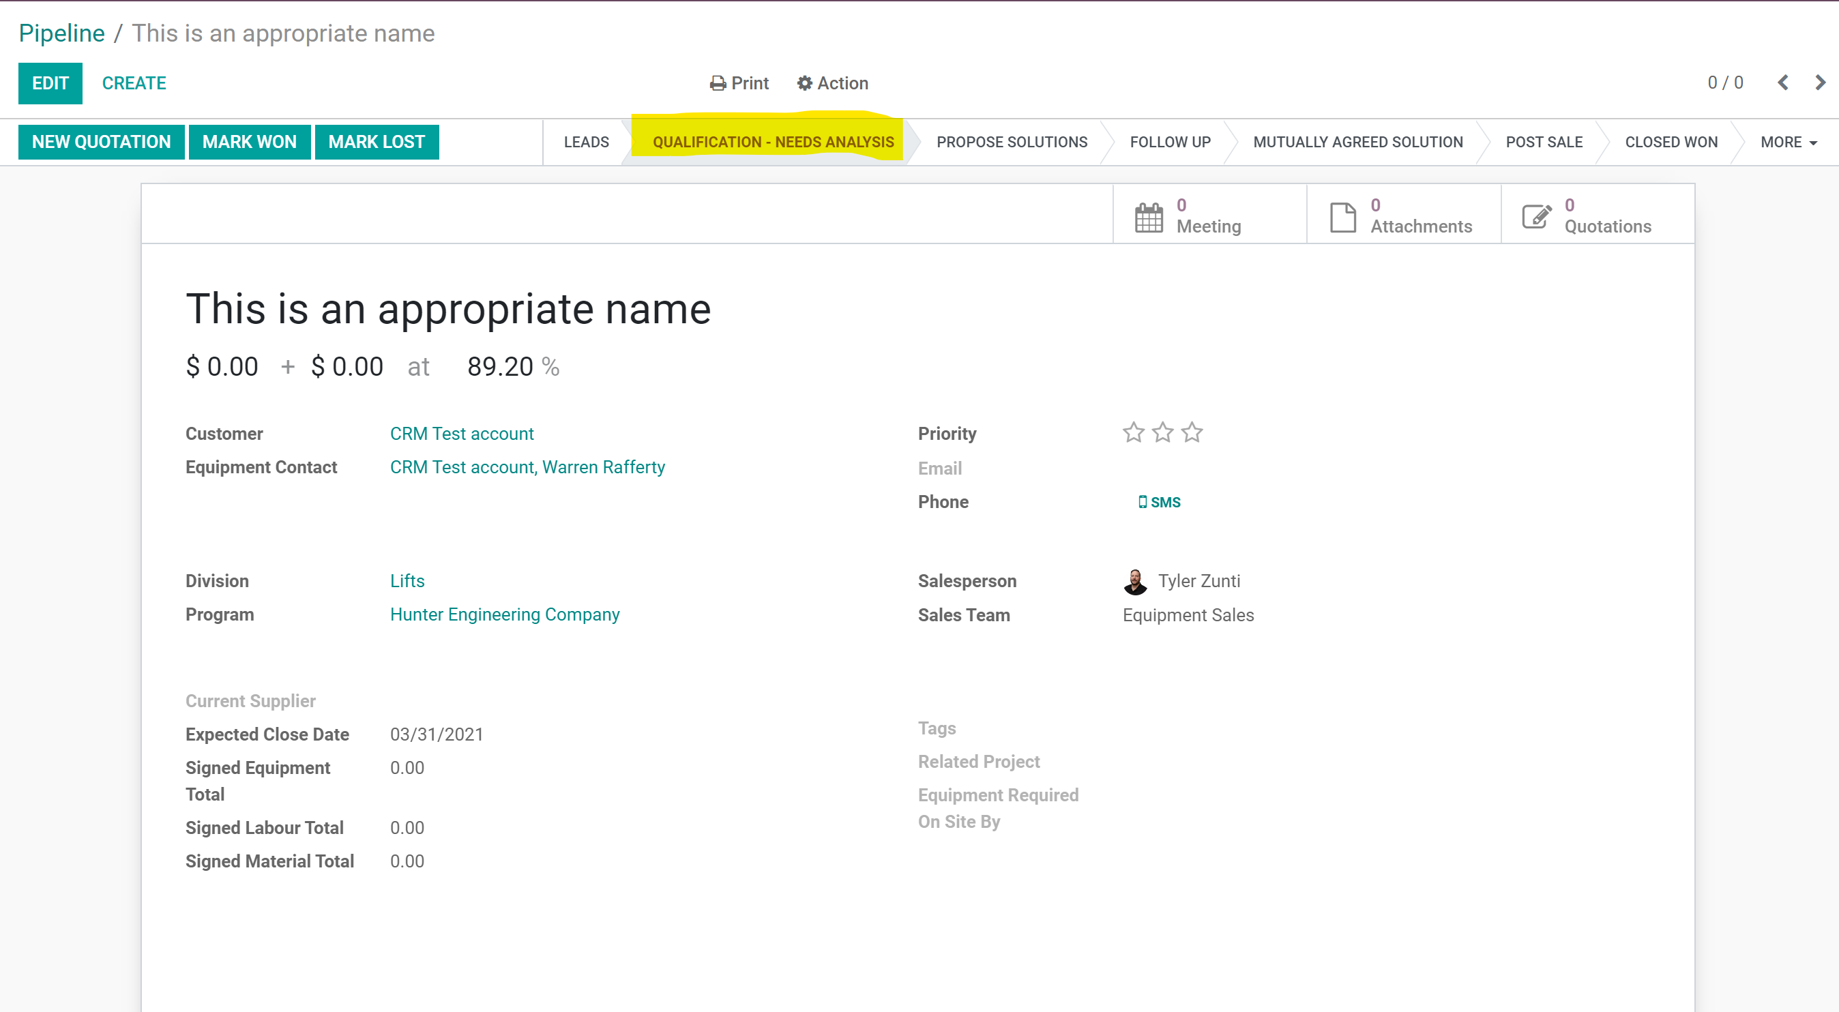
- When Sarah completes the quote she will log a note, attach it into the potential and move the stage to Propose Products/Solutions. Sarah will also enter the expected revenue.
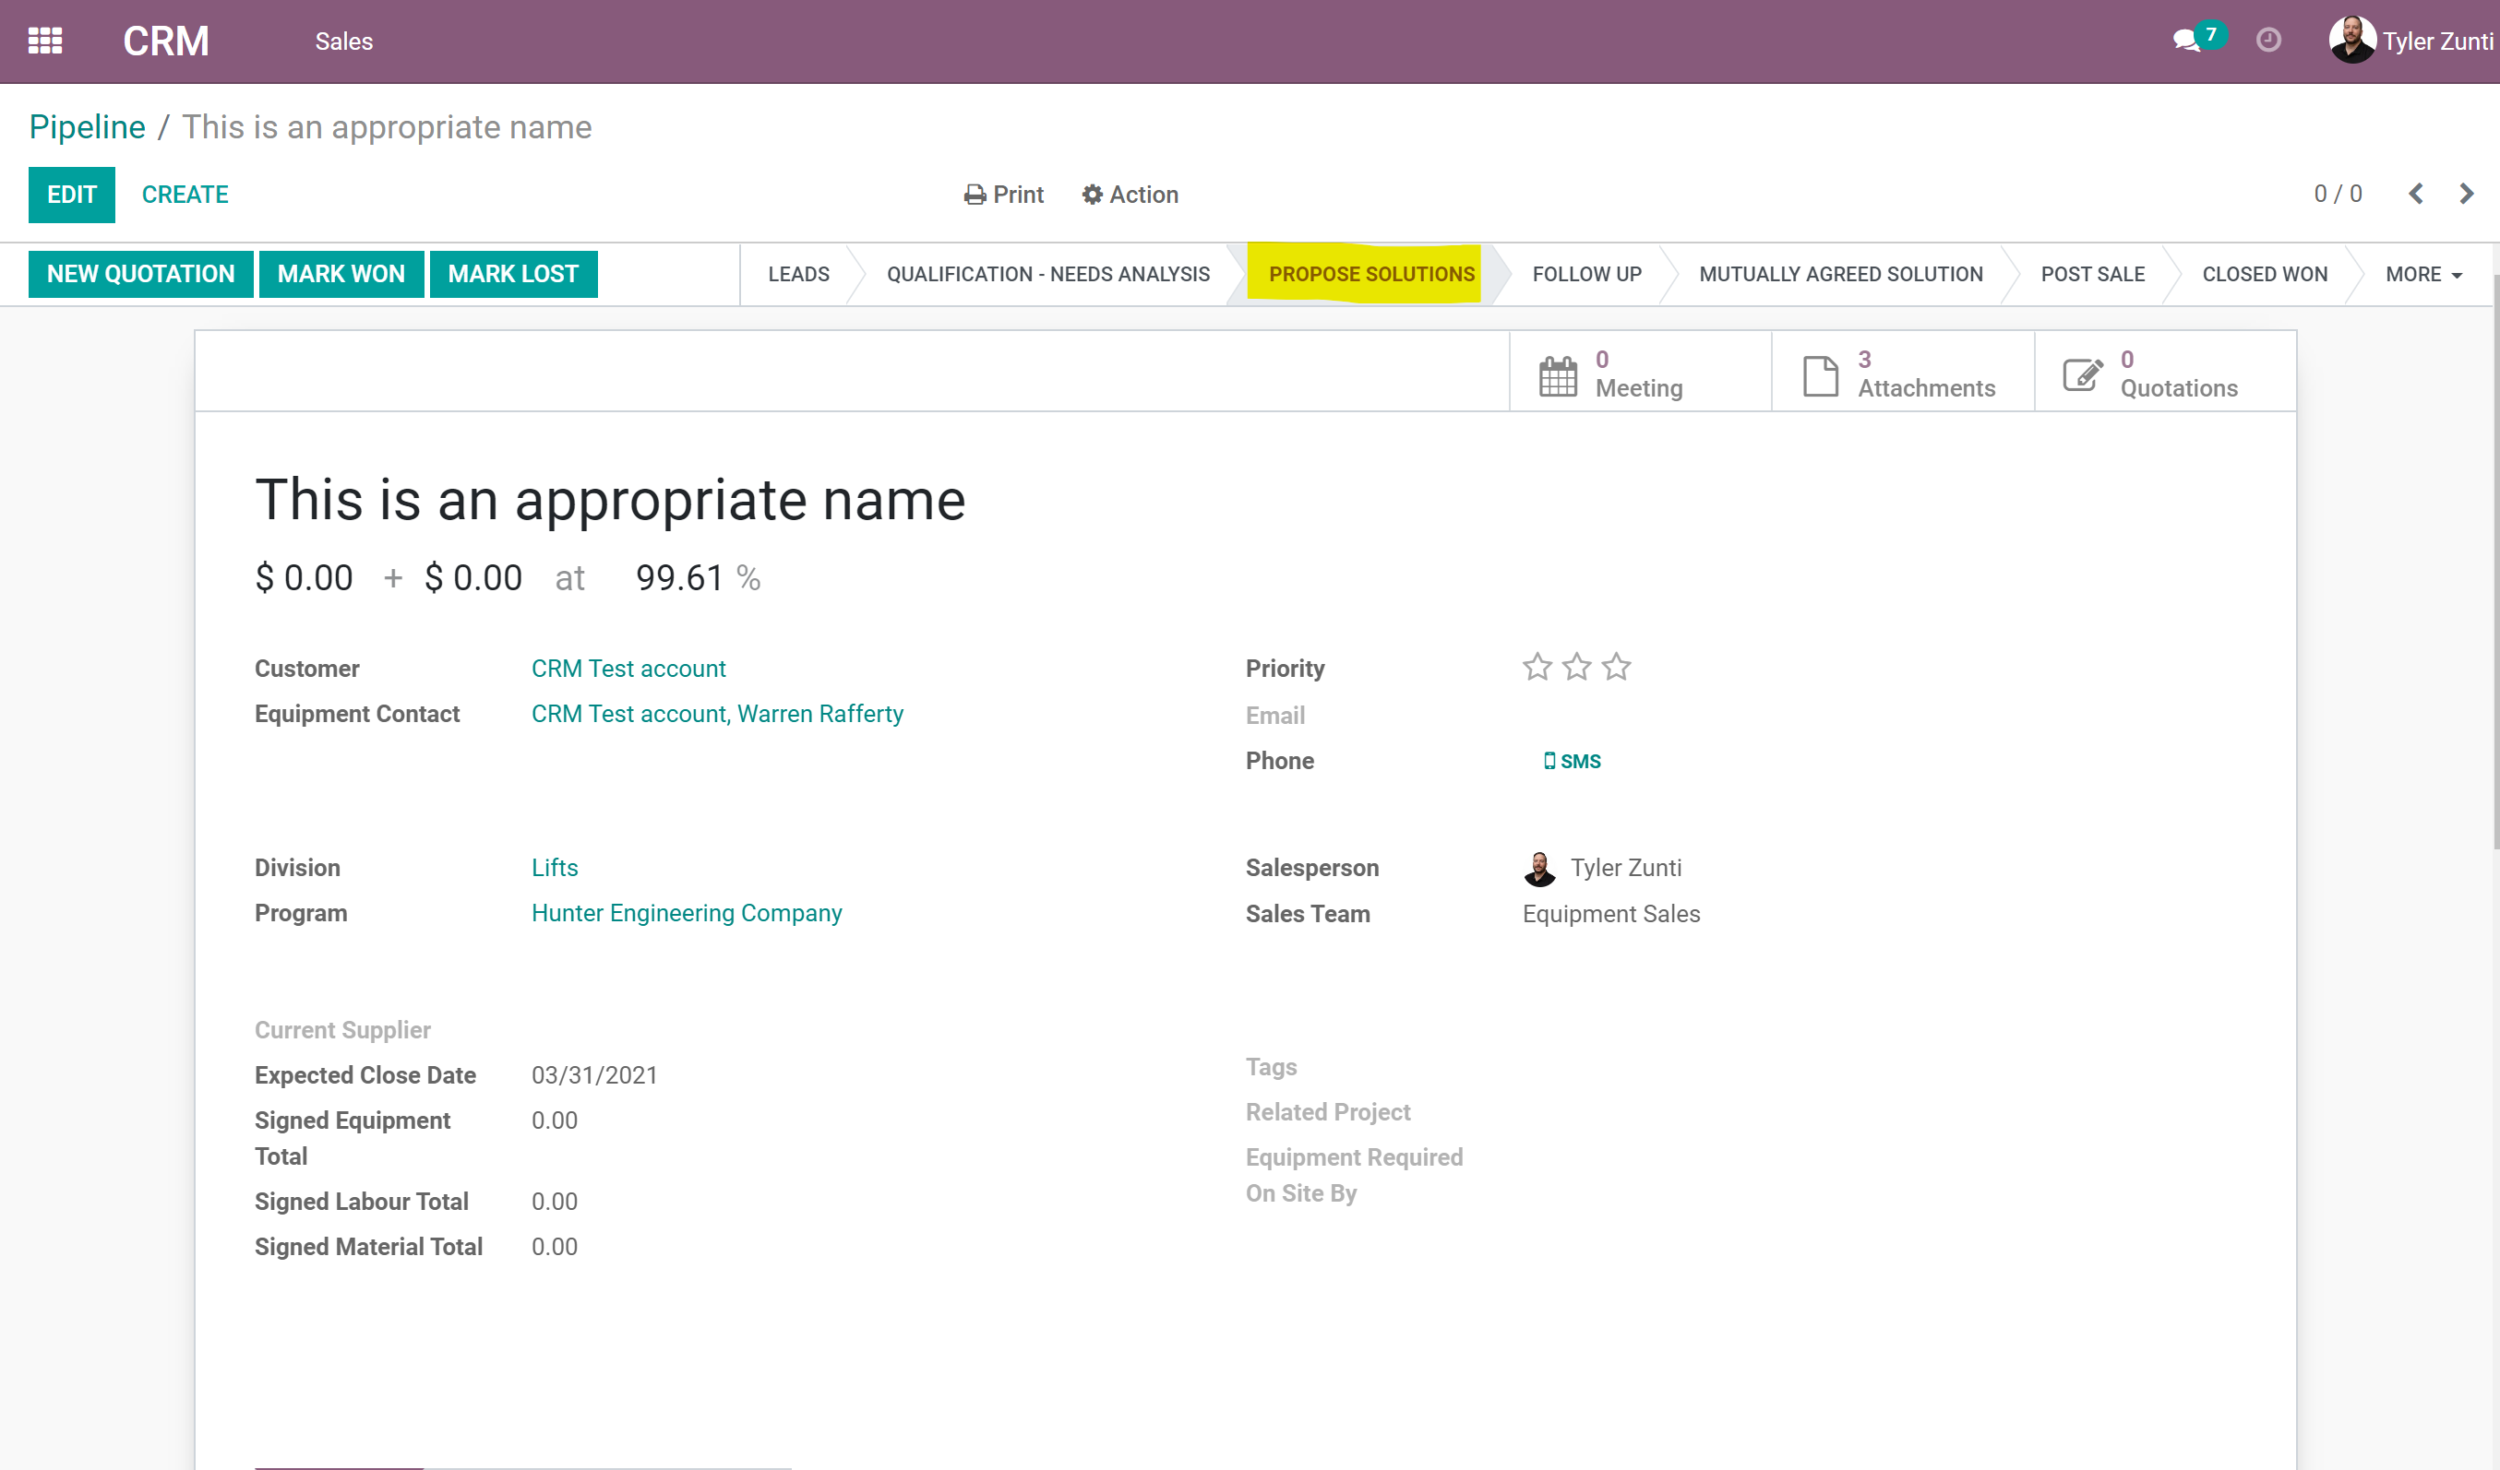
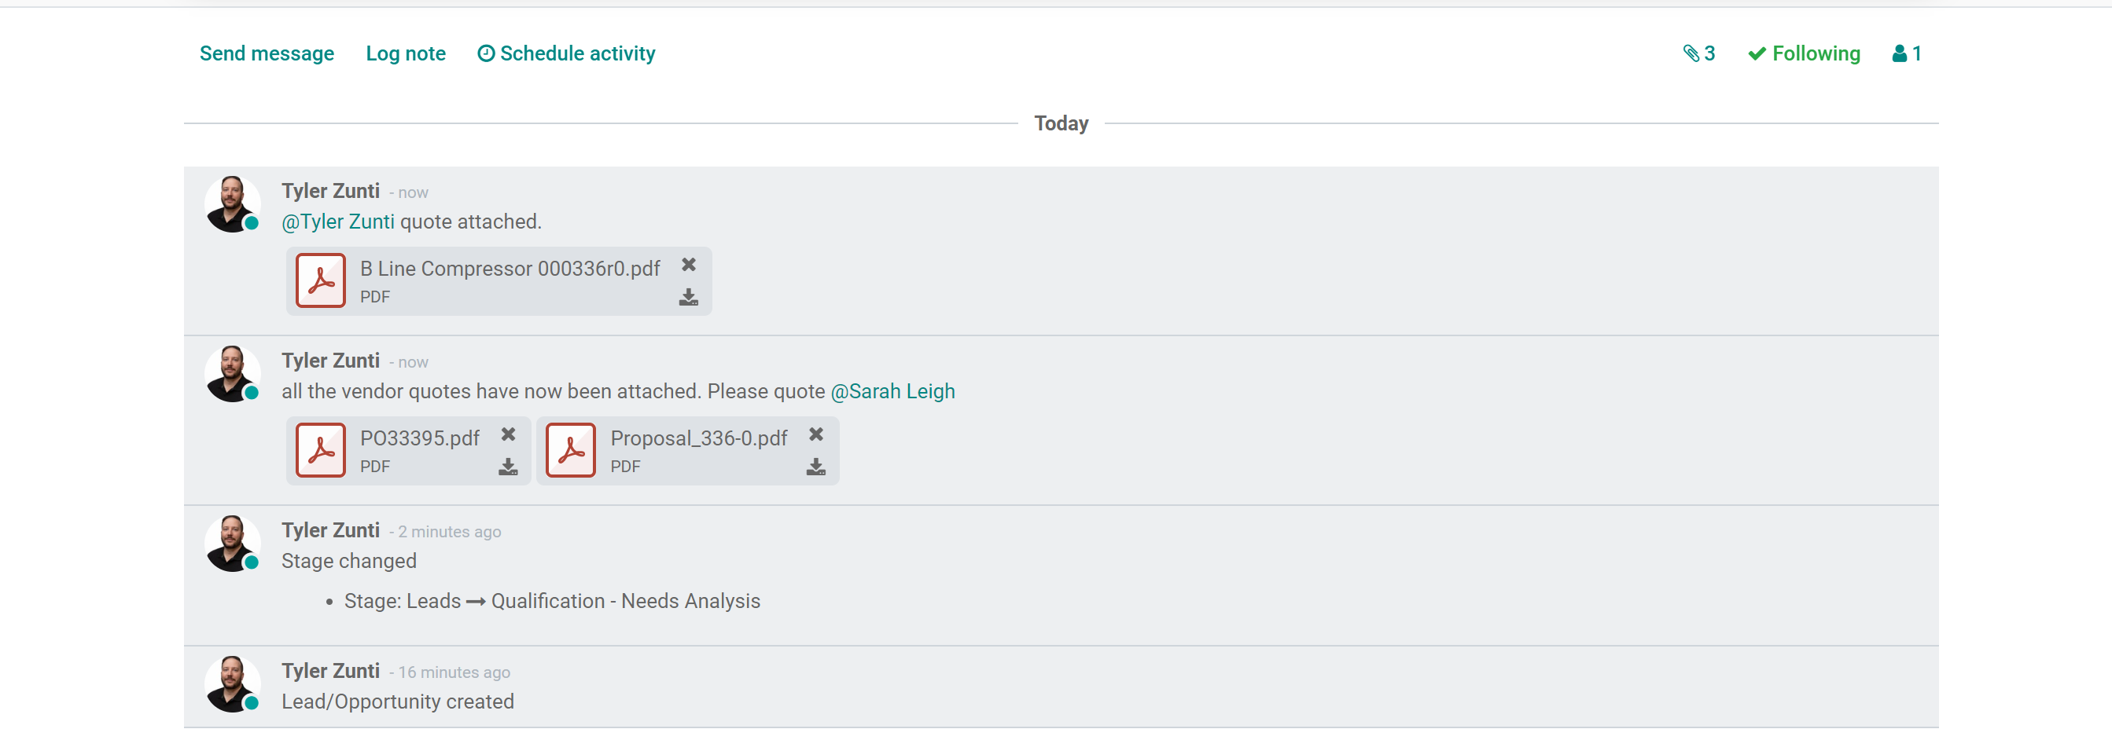

- Once you have presented the quote to the customer move the stage into FOLLOW UP and log a note.
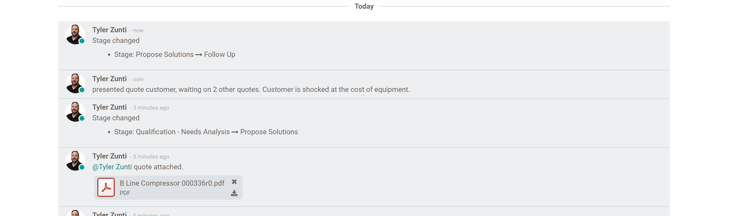
- From follow up it can move to Mutually Agreed Solution (Signed Order) or Qualification – Needs Analysis (Requote/revision). With each stage please “@” mention Sarah, appropriate pm’s and coordinator. (see below for more info.) You can not move a potential into MAS without the date required by filled in.

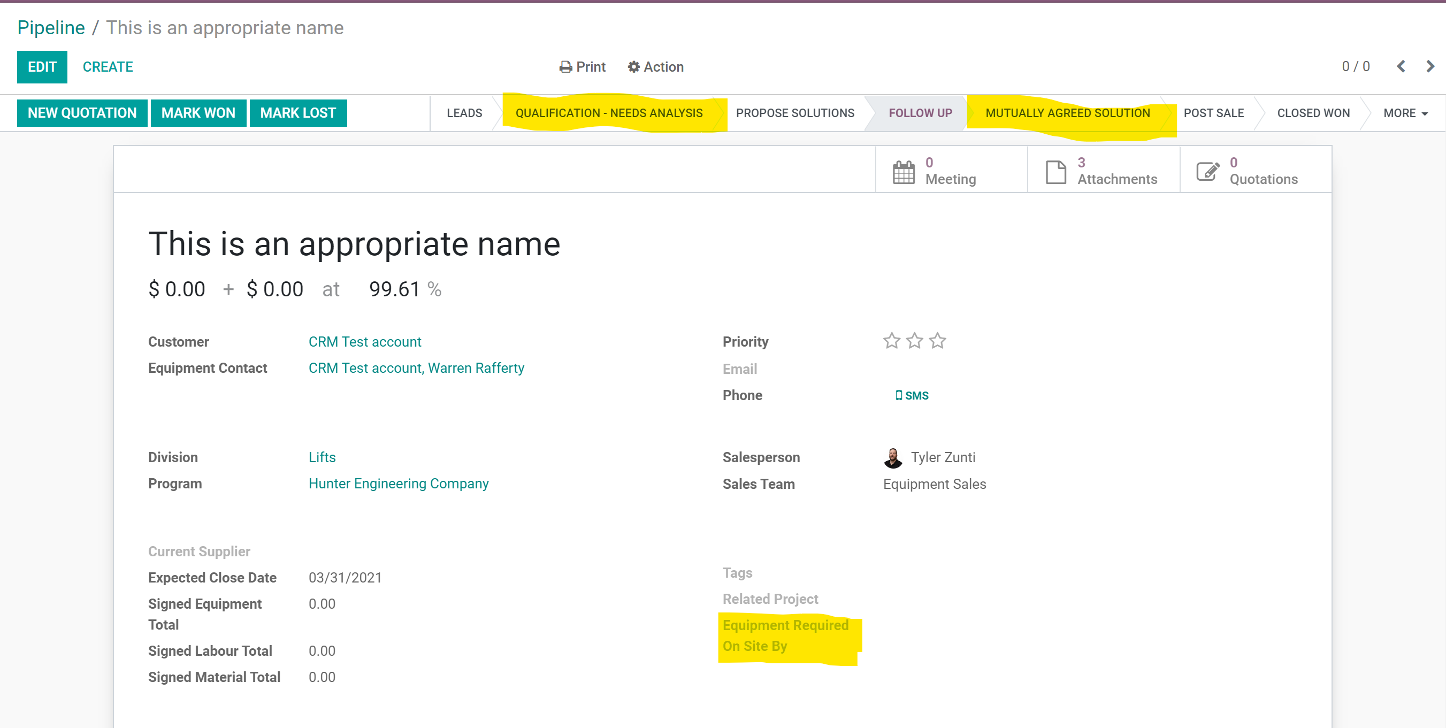

  - Sales reps need to fill in the signed equipment, material and labour totals.
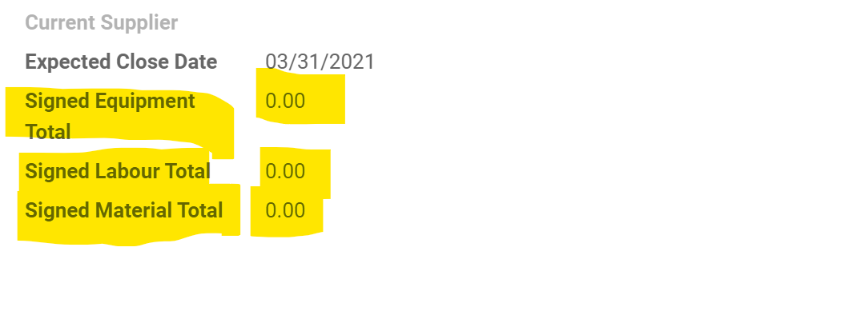
  - For a one off/immediate sales please “@” mention Franco or Guy to coordinate delivery of equipment and crews.
  - For any sale that is supply only check supply only and include a date.
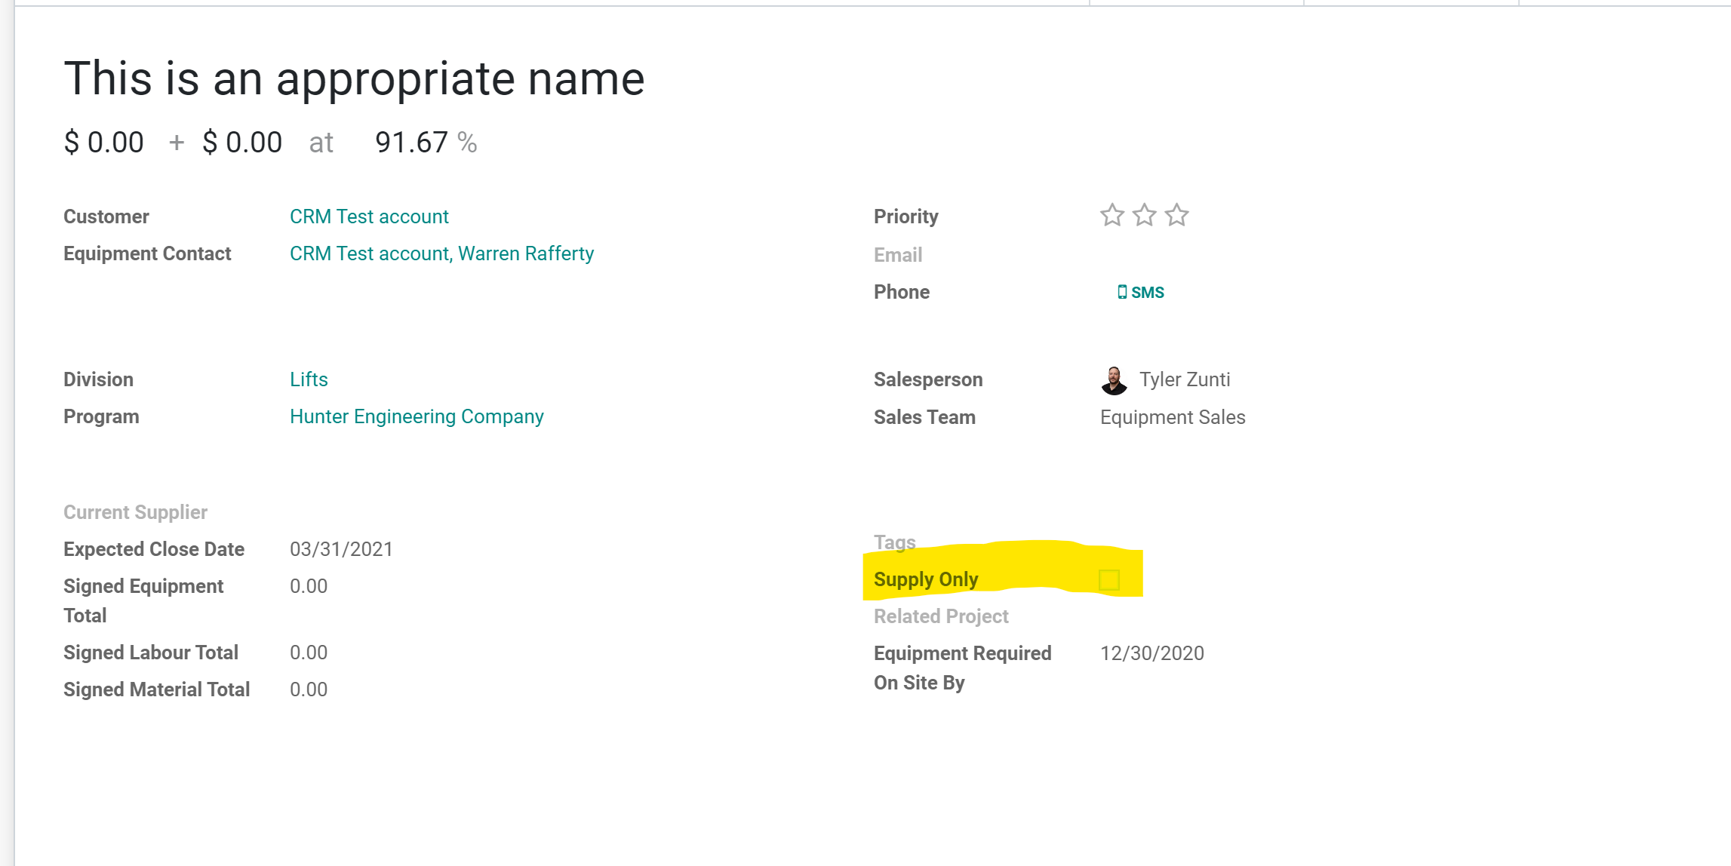
  - For a project “@” mention the appropriate PM and include it in a project.

- From MAS the office staff will move into Post Sale. This indicates that we are arranging po’s to vendors for equipment and materials as well as arranging install dates. The install coordinator or service coordinator will be in touch with the customer to make arrangements. The details below will start to be filled in on the project field.
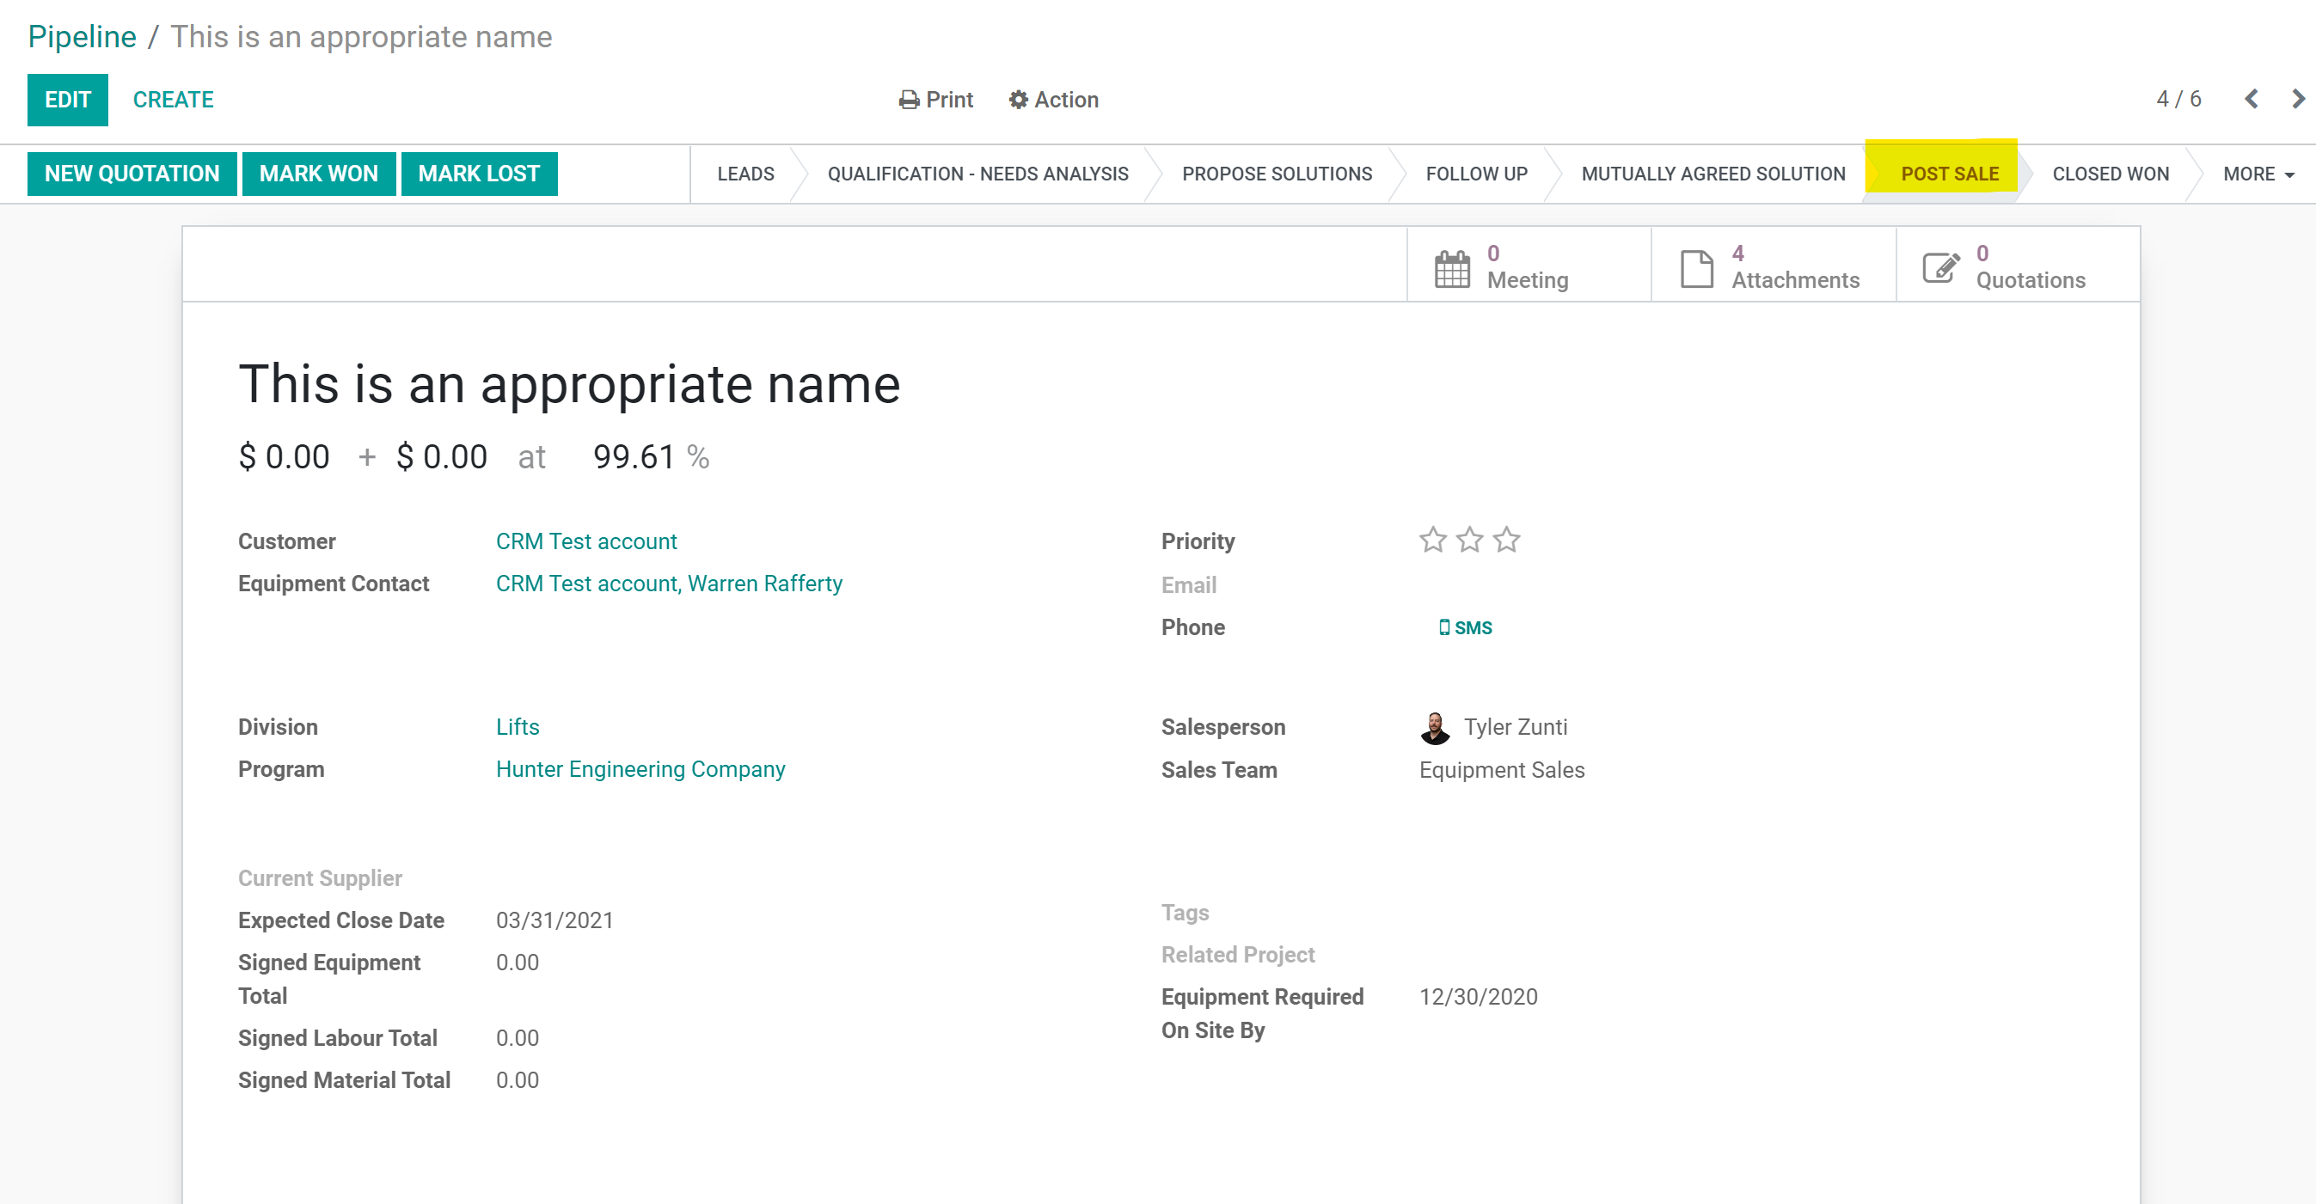

- Once the final invoicing has been completed it will be moved into Closed Won by the office staff.
